TAC Road Safety Statistics
December 2023

Contents
Status Report 3
Lives lost: Rolling 12 months 5
Injured claimants admitted to hospital within 7 days of the accident with a hospital stay of more than 14 days 7
Injured claimants who were admitted to hospital within 7 days of accident 9
Mobile Safety Camera Data 12
The National Picture 13
International Road Safety Comparison 14
Lives lost rate per 100,000 population - OECD countries, 2022. 15
Explanations and references 16
Useful websites 17
Graphs of Lives Lost and Hospitalised Claims 18
Victorian monthly lives lost since 1951 20

Notes about the data in this report
- All data provided in this report is the data most recently available at time of production. Fatality data updated to the end of report month. A 6-month lag applies to TAC claims data.
- Reported data will have one extra day of exposure for leap years.
- Data is subject to revision as additional information about known accidents/claims is received, and as new accident/claim reports are received and processed.

Status Report

Lives lost on Victorian roads
- In a 12-month period from 1st January 2023 to the end of December 2023, 295 people lost their lives compared to 241 lives lost during the previous 12-month period from January 2022 to the end of December 2022. This represents 54 more lives lost.

Category | 2023 | 2022 | 2021 | 2023 v 2022 | 2023 v 2021 | 5 Year Average
Lives Lost (Rolling 12 Month Total)
Lives Lost (to December) | 295 | 241 | 234 | +54 | +61 | 249
per 10,000 veh | 0.55 | 0.45 | 0.45 | +0.10 | +0.10 | 0.47
per 100,000 population | 4.33 | 3.64 | 3.57 | +0.69 | +0.76 | 3.66
Crashes (Rolling 12 Month Total)
Fatal crashes (to December) | 261 | 239 | 216 | +22 | +45 | 232
per 10,000 veh | 0.48 | 0.45 | 0.41 | +0.03 | +0.07 | 0.44
per 100,000 population | 3.83 | 3.61 | 3.30 | +0.22 | +0.53 | 3.42
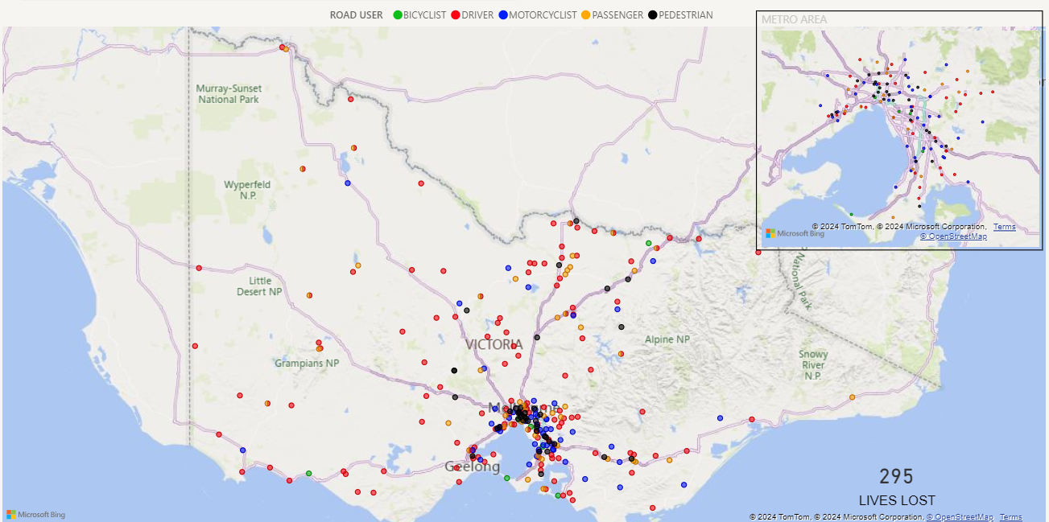

Victoria – Lives Lost, 12 months to December 2023

Injured claimants who were admitted to hospital within 7 days of accident
Rolling 12 month to 30th of June (claim acceptance date)
Category | 2023 | 2022 | 2021 | 2023 v 2022 |  | 2023 v 2021 |  | 5 Year Average
Claims involving a hospitalisation over 14 days (Rolling 12 Month Total)
Claims (to June) | 664 | 560 | 619 | +104 | (+19%) | 45 | (+7%) | 712
per 10,000 veh | 1.2 | 1.1 | 1.2 | +0.1 | (+9%) | 0.0 | (+0%) | 1.4
per 100,000 population | 9.9 | 8.5 | 9.2 | +1.4 | (+16%) | +0.7 | (+8%) | 11.1
All claims involving a hospitalisation (Rolling 12 Month Total)
Claims (to June) | 5,602 | 5,103 | 5,662 | +499 | (+10%) | -60 | (-1%) | 6,297
per 10,000 veh | 10.5 | 9.7 | 10.9 | 0.8 | (+8%) | -0.4 | (-4%) | 12.7
per 100,000 population | 83.4 | 77.5 | 83.9 | 5.9 | (+8%) | -0.5 | (-1%) | 98.9
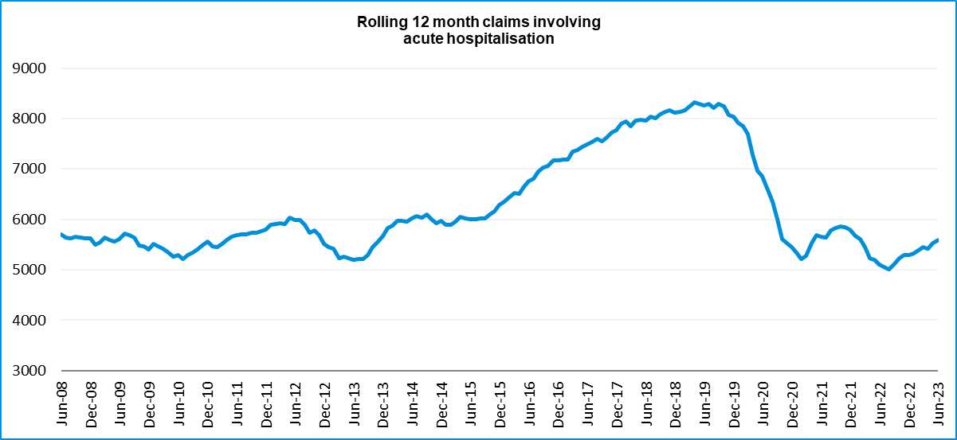

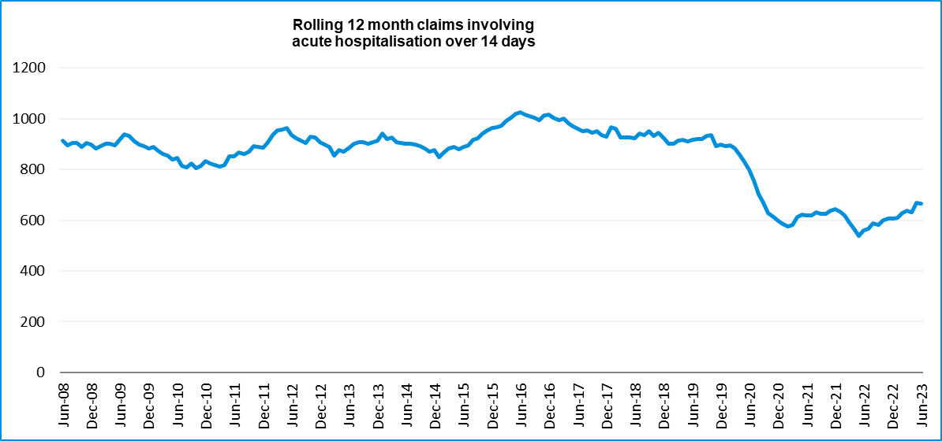

Lives lost: Rolling 12 months.

12 months to 31st December 2023
Category | 2023 | 2022 | 2021 | 2023 v 2022 | 2023 v 2021 | 5 Year Average
Overview
Lives Lost | 295 | 241 | 234 | +54 | +61 | 249
Fatal Crashes | 261 | 239 | 216 | +22 | +45 | 232
Sex
Female | 89 | 61 | 64 | +28 | +25 | 67
Male | 205 | 179 | 170 | +26 | +35 | 182
Road user
Bicyclist | 8 | 12 | 12 | -4 | -4 | 11
Driver | 128 | 101 | 114 | +27 | +14 | 112
Motorcyclist | 53 | 57 | 43 | -4 | +10 | 46
Passenger | 62 | 27 | 35 | +35 | +27 | 41
Pedestrian | 44 | 43 | 29 | +1 | +15 | 39
Location
Melbourne | 122 | 106 | 114 | +16 | +8 | 109
Rural Victoria | 173 | 135 | 120 | +38 | +53 | 140
Age group
0-4 | 4 | 3 | 4 | +1 | 0 | 3
5-15 | 8 | 4 | 5 | +4 | +3 | 5
16-17 | 7 | 3 | 8 | +4 | -1 | 6
18-20 | 25 | 20 | 12 | +5 | +13 | 18
21-25 | 27 | 19 | 23 | +8 | +4 | 23
26-29 | 26 | 22 | 18 | +4 | +8 | 22
30-39 | 46 | 33 | 31 | +13 | +15 | 37
40-49 | 28 | 34 | 28 | -6 | 0 | 29
50-59 | 31 | 32 | 25 | -1 | +6 | 29
60-69 | 35 | 31 | 33 | +4 | +2 | 31
70+ | 57 | 40 | 45 | 17 | 12 | 47
Accident Type
Intersection
Adjacent direction | 50 | 29 | 23 | +21 | +27 | 31
Opposing direction | 11 | 12 | 10 | -1 | +1 | 10
Mid-block/other
Head on | 39 | 27 | 32 | +12 | +7 | 31
Same direction | 18 | 26 | 23 | -8 | -5 | 22
Manoeuvre/o'taking | 13 | 10 | 9 | +3 | +4 | 13
On path | 5 | 7 | 3 | -2 | +2 | 5
Single vehicle | 113 | 83 | 103 | +30 | +10 | 94
Other (incl peds) | 46 | 47 | 31 | -1 | +15 | 43

Lives Lost: 12 months to 31st December 2023
Category | 2023 | 2022 | 2021 | 5 Year Average | Category | 2023 | 2022 | 2021 | 5 Year Average
Local Government Area |  |  |  |  | Local Government Area
ALPINE | 0 | 3 | 0 | 2 | MANSFIELD | 5 | 2 | 0 | 1
ARARAT | 0 | 1 | 1 | 1 | MARIBYRNONG | 1 | 2 | 0 | 2
BALLARAT | 1 | 4 | 3 | 3 | MAROONDAH | 2 | 2 | 2 | 2
BANYULE | 3 | 2 | 1 | 1 | MELBOURNE | 4 | 2 | 6 | 3
BASS COAST | 6 | 3 | 0 | 2 | MELTON | 2 | 4 | 8 | 4
BAW BAW | 7 | 2 | 8 | 4 | MILDURA | 2 | 5 | 2 | 4
BAYSIDE | 0 | 0 | 1 | 1 | MITCHELL | 4 | 6 | 7 | 4
BENALLA | 3 | 0 | 2 | 1 | MOIRA | 12 | 6 | 3 | 4
BOROONDARA | 2 | 1 | 1 | 3 | MONASH | 6 | 4 | 5 | 5
BRIMBANK | 6 | 11 | 6 | 6 | MOONEE VALLEY | 4 | 1 | 2 | 2
BULOKE | 3 | 0 | 2 | 1 | MOORABOOL | 3 | 2 | 2 | 3
CAMPASPE | 6 | 8 | 3 | 4 | Merri-Bek | 2 | 5 | 0 | 2
CARDINIA | 4 | 5 | 14 | 6 | MORNINGTON PENINSULA | 6 | 4 | 9 | 7
CASEY | 14 | 9 | 14 | 7 | MOUNT ALEXANDER | 0 | 1 | 2 | 3
CENTRAL GOLDFIELDS | 0 | 1 | 0 | 1 | MOYNE | 4 | 1 | 4 | 2
COLAC-OTWAY | 0 | 6 | 3 | 3 | MURRINDINDI | 3 | 7 | 2 | 3
CORANGAMITE | 3 | 6 | 3 | 3 | NILLUMBIK | 2 | 1 | 2 | 2
DAREBIN | 2 | 1 | 2 | 2 | NORTHERN GRAMPIANS | 3 | 3 | 5 | 3
EAST GIPPSLAND | 3 | 2 | 4 | 4 | PORT PHILLIP | 0 | 5 | 0 | 2
FRANKSTON | 7 | 0 | 2 | 3 | PYRENEES | 1 | 1 | 2 | 1
GANNAWARRA | 1 | 2 | 0 | 1 | QUEENSCLIFFE | 0 | 0 | 0 | 0
GLEN EIRA | 2 | 1 | 3 | 2 | SOUTH GIPPSLAND | 3 | 5 | 2 | 5
GLENELG | 3 | 2 | 2 | 2 | SOUTHERN GRAMPIANS | 6 | 0 | 1 | 1
GOLDEN PLAINS | 3 | 1 | 1 | 2 | STONNINGTON | 1 | 0 | 2 | 1
GREATER BENDIGO | 8 | 4 | 5 | 5 | STRATHBOGIE | 7 | 4 | 2 | 2
GREATER DANDENONG | 4 | 4 | 5 | 3 | SURF COAST | 2 | 1 | 2 | 1
GREATER GEELONG | 11 | 10 | 8 | 9 | SWAN HILL | 3 | 1 | 2 | 1
GREATER SHEPPARTON | 14 | 6 | 3 | 5 | TOWONG | 2 | 2 | 2 | 2
HEPBURN | 7 | 2 | 1 | 3 | WANGARATTA | 5 | 2 | 3 | 2
HINDMARSH | 0 | 0 | 1 | 0 | WARRNAMBOOL | 1 | 1 | 3 | 2
HOBSONS BAY | 3 | 4 | 3 | 2 | WELLINGTON | 3 | 7 | 5 | 4
HORSHAM | 0 | 1 | 4 | 3 | WEST WIMMERA | 2 | 0 | 1 | 1
HUME | 4 | 5 | 6 | 5 | WHITEHORSE | 3 | 1 | 1 | 1
INDIGO | 5 | 0 | 3 | 2 | WHITTLESEA | 5 | 8 | 4 | 4
KINGSTON | 2 | 1 | 2 | 3 | WODONGA | 1 | 3 | 0 | 1
KNOX | 2 | 2 | 1 | 2 | WYNDHAM | 11 | 6 | 6 | 6
LATROBE | 6 | 6 | 4 | 5 | YARRA | 3 | 5 | 2 | 2
LODDON | 3 | 2 | 3 | 2 | YARRA RANGES | 11 | 7 | 4 | 6
MACEDON RANGES | 3 | 3 | 3 | 3 | YARRIAMBIACK | 4 | 0 | 1 | 0
MANNINGHAM | 4 | 3 | 0 | 1

Injured claimants admitted to hospital within 7 days of the accident with a hospital stay of more than 14 days.
12 months to 30th June 2023 (claim acceptance date, excludes rejected claims and claims for interstate crashes.)
Category | 2023 | 2022 | 2021 | 2023 v 2022 |  | 2023 v 2021 |  | 5 Year Average
Overview
Claims | 664 | 560 | 619 | +104 | 19% | 45 | 7% | 712
Sex
Female | 246 | 207 | 222 | +39 | 19% | 24 | 11% | 274
Male | 416 | 353 | 397 | +63 | 18% | 19 | 5% | 438
Road user
Bicyclist | 29 | 30 | 31 | -1 | -3% | -2 | -6% | 32
Driver | 231 | 218 | 234 | +13 | 6% | -3 | -1% | 268
Motorcyclist | 153 | 114 | 138 | +39 | 34% | 15 | 11% | 148
Passenger | 72 | 64 | 81 | +8 | 13% | -9 | -11% | 94
Pedestrian | 161 | 121 | 123 | +40 | 33% | 38 | 31% | 150
Train/Tram | 2 | 6 | 5 | -4 | -67% | -3 | -60% | 6
Location
Melbourne | 409 | 328 | 352 | +81 | 25% | 57 | 16% | 422
Rural Victoria | 233 | 211 | 237 | +22 | 10% | -4 | -2% | 257
Age group
0-4 | 0 | 3 | 3 | -3 | -100% | -3 | -100% | 3
5-15 | 15 | 8 | 6 | +7 | 88% | 9 | 150% | 12
16-17 | 11 | 11 | 13 |  | 0% | -2 | -15% | 13
18-20 | 33 | 27 | 32 | +6 | 22% | 1 | 3% | 35
21-25 | 46 | 41 | 55 | +5 | 12% | -9 | -16% | 55
26-29 | 32 | 36 | 46 | -4 | -11% | -14 | -30% | 42
30-39 | 95 | 73 | 85 | +22 | 30% | 10 | 12% | 89
40-49 | 72 | 71 | 69 | +1 | 1% | 3 | 4% | 82
50-59 | 99 | 63 | 77 | +36 | 57% | 22 | 29% | 92
60-69 | 68 | 81 | 84 | -13 | -16% | -16 | -19% | 92
70+ | 193 | 146 | 149 | +47 | 32% | 44 | 30% | 199
Accident Type
Intersection
Adjacent direction | 75 | 68 | 61 | +7 | 10% | 14 | 23% | 72
Opposing direction | 42 | 45 | 29 | -3 | -7% | 13 | 45% | 44
Mid-block/other
Head on | 53 | 41 | 35 | +12 | 29% | 18 | 51% | 51
Same direction | 49 | 43 | 45 | +6 | 14% | 4 | 9% | 56
Manoeuvre/o'taking | 45 | 36 | 40 | +9 | 25% | 5 | 13% | 43
On path | 23 | 27 | 26 | -4 | -15% | -3 | -12% | 27
Single vehicle | 170 | 134 | 206 | +36 | 27% | -36 | -17% | 197
Other (incl peds) | 207 | 166 | 177 | +41 | 25% | 30 | 17% | 222

Injured claimants who were admitted to hospital within 7 days of the accident with a hospital stay of more than 14 days

12 months to 30th June 2023 (claim acceptance date, excludes rejected claims and claims for interstate crashes.) – Continued
Category | 2023 | 2022 | 2021 | 5 Year Average | Category | 2023 | 2022 | 2021 | 5 Year Average
Local Government Area |  |  |  |  | Local Government Area
ALPINE | 3 | 5 | 5 | 5 | MANSFIELD | 6 | 0 | 6 | 3
ARARAT | 4 | 0 | 0 | 2 | MARIBYRNONG | 12 | 9 | 6 | 7
BALLARAT | 12 | 11 | 17 | 13 | MAROONDAH | 6 | 4 | 8 | 7
BANYULE | 8 | 9 | 5 | 6 | MELBOURNE | 16 | 16 | 24 | 18
BASS COAST | 10 | 6 | 5 | 5 | MELTON | 16 | 5 | 6 | 5
BAW BAW | 8 | 6 | 1 | 5 | MILDURA | 3 | 7 | 3 | 5
BAYSIDE | 5 | 6 | 2 | 5 | MITCHELL | 8 | 5 | 11 | 7
BENALLA | 4 | 3 | 2 | 2 | MOIRA | 8 | 5 | 8 | 5
BOROONDARA | 7 | 6 | 12 | 10 | MONASH | 26 | 7 | 10 | 12
BRIMBANK | 16 | 18 | 17 | 14 | MOONEE VALLEY | 10 | 17 | 7 | 10
BULOKE | 1 | 1 | 2 | 2 | MOORABOOL | 7 | 6 | 3 | 5
CAMPASPE | 5 | 8 | 5 | 6 | Merri-Bek | 16 | 17 | 11 | 15
CARDINIA | 10 | 14 | 13 | 11 | MORNINGTON PENINSULA | 18 | 9 | 11 | 13
CASEY | 20 | 18 | 16 | 18 | MOUNT ALEXANDER | 5 | 2 | 9 | 3
CENTRAL GOLDFIELDS | 4 | 2 | 3 | 3 | MOYNE | 4 | 1 | 1 | 3
COLAC-OTWAY | 2 | 7 | 7 | 5 | MURRINDINDI | 3 | 3 | 2 | 4
CORANGAMITE | 3 | 4 | 4 | 2 | NILLUMBIK | 5 | 4 | 6 | 6
DAREBIN | 17 | 13 | 13 | 12 | NORTHERN GRAMPIANS | 3 | 1 | 2 | 1
EAST GIPPSLAND | 16 | 4 | 11 | 8 | PORT PHILLIP | 8 | 8 | 10 | 9
FRANKSTON | 7 | 7 | 4 | 6 | PYRENEES | 0 | 0 | 2 | 2
GANNAWARRA | 2 | 2 | 3 | 2 | QUEENSCLIFFE | 0 | 0 | 0 | 1
GLEN EIRA | 2 | 4 | 5 | 9 | SOUTH GIPPSLAND | 5 | 5 | 3 | 4
GLENELG | 2 | 4 | 0 | 2 | SOUTHERN GRAMPIANS | 1 | 0 | 3 | 3
GOLDEN PLAINS | 1 | 7 | 1 | 4 | STONNINGTON | 13 | 13 | 11 | 8
GREATER BENDIGO | 12 | 13 | 16 | 14 | STRATHBOGIE | 3 | 1 | 6 | 3
GREATER DANDENONG | 18 | 14 | 21 | 19 | SURF COAST | 2 | 4 | 4 | 4
GREATER GEELONG | 26 | 25 | 23 | 23 | SWAN HILL | 0 | 2 | 3 | 3
GREATER SHEPPARTON | 8 | 13 | 18 | 10 | TOWONG | 1 | 3 | 0 | 2
HEPBURN | 5 | 2 | 7 | 4 | WANGARATTA | 2 | 2 | 0 | 3
HINDMARSH | 1 | 0 | 0 | 1 | WARRNAMBOOL | 4 | 6 | 3 | 3
HOBSONS BAY | 8 | 4 | 6 | 5 | WELLINGTON | 3 | 8 | 10 | 8
HORSHAM | 4 | 5 | 0 | 2 | WEST WIMMERA | 1 | 0 | 0 | 0
HUME | 18 | 24 | 15 | 18 | WHITEHORSE | 22 | 12 | 11 | 14
INDIGO | 5 | 2 | 7 | 4 | WHITTLESEA | 19 | 18 | 14 | 17
KINGSTON | 9 | 8 | 14 | 11 | WODONGA | 4 | 5 | 3 | 3
KNOX | 16 | 12 | 17 | 15 | WYNDHAM | 19 | 15 | 21 | 15
LATROBE | 10 | 8 | 11 | 9 | YARRA | 9 | 5 | 8 | 8
LODDON | 4 | 1 | 1 | 2 | YARRA RANGES | 22 | 9 | 20 | 17
MACEDON RANGES | 6 | 6 | 5 | 7 | YARRIAMBIACK | 2 | 0 | 1 | 1
MANNINGHAM | 11 | 3 | 8 | 8

Injured claimants who were admitted to hospital within 7 days of accident.
12 months to 30th June 2023 (claim acceptance date, excludes rejected claims and claims for interstate crashes.)
Category | 2023 | 2022 | 2021 | 2023 v 2022 |  | 2023 v 2021 |  | 5 Year Average
Overview
Claims | 5,602 | 5,103 | 5,662 | +499 | 10% | -60 | -1% | 6,297
Sex
Female | 2,317 | 2,113 | 2,300 | +204 | 10% | +17 | 1% | 2,648
Male | 3,266 | 2,987 | 3,353 | +279 | 9% | -87 | -3% | 3,639
Road user
Bicyclist | 374 | 350 | 429 | +24 | 7% | -55 | -13% | 429
Driver | 2,648 | 2,493 | 2,782 | +155 | 6% | -134 | -5% | 3,076
Motorcyclist | 983 | 911 | 1,042 | +72 | 8% | -59 | -6% | 1,071
Passenger | 750 | 668 | 731 | +82 | 12% | +19 | 3% | 862
Pedestrian | 652 | 528 | 509 | +124 | 23% | +143 | 28% | 625
Train/Tram | 24 | 15 | 12 | +9 | 60% | +12 | 100% | 25
Location
Melbourne | 3,653 | 3,262 | 3,490 | +391 | 12% | +163 | 5% | 3,932
Rural Victoria | 1,745 | 1,616 | 1,934 | +129 | 8% | -189 | -10% | 1,974
Age group
0-4 | 26 | 28 | 38 | -2 | -7% | -12 | -32% | 39
5-15 | 176 | 117 | 150 | +59 | 50% | +26 | 17% | 170
16-17 | 94 | 94 | 95 |  | 0% | -1 | -1% | 105
18-20 | 332 | 317 | 427 | +15 | 5% | -95 | -22% | 439
21-25 | 574 | 582 | 666 | -8 | -1% | -92 | -14% | 725
26-29 | 408 | 427 | 492 | -19 | -4% | -84 | -17% | 519
30-39 | 965 | 894 | 984 | +71 | 8% | -19 | -2% | 1,054
40-49 | 753 | 692 | 788 | +61 | 9% | -35 | -4% | 861
50-59 | 770 | 732 | 753 | +38 | 5% | +17 | 2% | 858
60-69 | 652 | 580 | 587 | +72 | 12% | +65 | 11% | 680
70+ | 852 | 640 | 682 | +212 | 33% | +170 | 25% | 847
Accident Type
Intersection
Adjacent direction | 860 | 787 | 845 | +73 | 9% | +15 | 2% | 880
Opposing direction | 435 | 406 | 432 | +29 | 7% | +3 | 1% | 466
Mid-block/other
Head on | 289 | 248 | 275 | +41 | 17% | +14 | 5% | 303
Same direction | 911 | 809 | 879 | +102 | 13% | +32 | 4% | 932
Manoeuvre/o'taking | 348 | 350 | 401 | -2 | -1% | -53 | -13% | 371
On path | 231 | 287 | 269 | -56 | -20% | -38 | -14% | 266
Single vehicle | 1,225 | 1,148 | 1,466 | +77 | 7% | -241 | -16% | 1,361
Other (incl peds) | 1,303 | 1,068 | 1,095 | +235 | 22% | +208 | 19% | 1,719

Injured claimants who were admitted to hospital within 7 days of accident

12 months to 30th June 2023 (claim acceptance date, excludes rejected claims and claims for interstate crashes.) – Continued
Category | 2023 | 2022 | 2021 | 5 Year Average | Category | 2023 | 2022 | 2021 | 5 Year Average
Local Government Area |  |  |  |  | Local Government Area
ALPINE | 26 | 27 | 30 | 24 | MANSFIELD | 25 | 22 | 35 | 27
ARARAT | 12 | 10 | 13 | 11 | MARIBYRNONG | 69 | 64 | 55 | 64
BALLARAT | 83 | 93 | 119 | 84 | MAROONDAH | 36 | 37 | 45 | 46
BANYULE | 38 | 31 | 39 | 39 | MELBOURNE | 191 | 166 | 161 | 175
BASS COAST | 37 | 30 | 38 | 34 | MELTON | 110 | 87 | 59 | 66
BAW BAW | 70 | 50 | 45 | 46 | MILDURA | 17 | 22 | 45 | 29
BAYSIDE | 63 | 72 | 66 | 64 | MITCHELL | 47 | 43 | 63 | 52
BENALLA | 14 | 11 | 11 | 14 | MOIRA | 22 | 35 | 33 | 30
BOROONDARA | 93 | 76 | 97 | 92 | MONASH | 159 | 113 | 142 | 129
BRIMBANK | 167 | 147 | 135 | 128 | MOONEE VALLEY | 120 | 129 | 102 | 106
BULOKE | 8 | 7 | 6 | 7 | MOORABOOL | 73 | 43 | 29 | 39
CAMPASPE | 36 | 33 | 46 | 34 | Merri-Bek | 131 | 136 | 109 | 125
CARDINIA | 99 | 119 | 110 | 96 | MORNINGTON PENINSULA | 157 | 116 | 145 | 130
CASEY | 266 | 281 | 317 | 253 | MOUNT ALEXANDER | 18 | 11 | 23 | 17
CENTRAL GOLDFIELDS | 13 | 11 | 17 | 16 | MOYNE | 30 | 24 | 13 | 22
COLAC-OTWAY | 43 | 58 | 50 | 46 | MURRINDINDI | 47 | 30 | 34 | 36
CORANGAMITE | 28 | 24 | 32 | 23 | NILLUMBIK | 30 | 23 | 31 | 29
DAREBIN | 93 | 62 | 60 | 75 | NORTHERN GRAMPIANS | 20 | 9 | 22 | 14
EAST GIPPSLAND | 54 | 30 | 58 | 38 | PORT PHILLIP | 132 | 102 | 142 | 110
FRANKSTON | 91 | 83 | 98 | 96 | PYRENEES | 15 | 7 | 7 | 9
GANNAWARRA | 13 | 11 | 10 | 9 | QUEENSCLIFFE | 1 | 1 | 4 | 4
GLEN EIRA | 90 | 81 | 104 | 93 | SOUTH GIPPSLAND | 38 | 24 | 37 | 30
GLENELG | 21 | 17 | 23 | 18 | SOUTHERN GRAMPIANS | 17 | 6 | 17 | 16
GOLDEN PLAINS | 30 | 34 | 35 | 32 | STONNINGTON | 130 | 85 | 122 | 94
GREATER BENDIGO | 80 | 99 | 106 | 98 | STRATHBOGIE | 26 | 15 | 33 | 24
GREATER DANDENONG | 185 | 199 | 237 | 203 | SURF COAST | 49 | 45 | 78 | 49
GREATER GEELONG | 343 | 371 | 360 | 321 | SWAN HILL | 8 | 19 | 16 | 16
GREATER SHEPPARTON | 47 | 46 | 74 | 60 | TOWONG | 10 | 8 | 13 | 11
HEPBURN | 48 | 26 | 30 | 25 | WANGARATTA | 26 | 20 | 21 | 25
HINDMARSH | 7 | 4 | 5 | 9 | WARRNAMBOOL | 17 | 26 | 24 | 23
HOBSONS BAY | 72 | 57 | 51 | 58 | WELLINGTON | 36 | 33 | 60 | 47
HORSHAM | 16 | 21 | 23 | 20 | WEST WIMMERA | 4 | 3 | 6 | 3
HUME | 215 | 220 | 193 | 189 | WHITEHORSE | 78 | 64 | 77 | 82
INDIGO | 18 | 18 | 18 | 18 | WHITTLESEA | 193 | 158 | 130 | 144
KINGSTON | 109 | 94 | 137 | 104 | WODONGA | 25 | 37 | 30 | 22
KNOX | 102 | 102 | 110 | 97 | WYNDHAM | 164 | 150 | 165 | 150
LATROBE | 65 | 36 | 83 | 62 | YARRA | 95 | 80 | 70 | 78
LODDON | 14 | 9 | 6 | 11 | YARRA RANGES | 125 | 99 | 138 | 118
MACEDON RANGES | 44 | 51 | 43 | 50 | YARRIAMBIACK | 4 | 6 | 10 | 6
MANNINGHAM | 50 | 29 | 43 | 48

Lives lost by week (2018 to 2023)
Week Ending | 2018 | 2019 | 2020 | 2021 | 2022 | 2023 | 2023 Cumulative | 12 month Moving Total
1-Jan | 2 | 0 | 3 | 0 | 2 | 0 | 0 | 239
8-Jan | 6 | 2 | 5 | 3 | 7 | 10 | 10 | 242
15-Jan | 4 | 5 | 5 | 1 | 6 | 4 | 14 | 240
22-Jan | 2 | 5 | 2 | 4 | 3 | 9 | 23 | 246
29-Jan | 5 | 7 | 5 | 6 | 4 | 7 | 30 | 249
5-Feb | 4 | 12 | 8 | 4 | 9 | 8 | 38 | 249
12-Feb | 2 | 7 | 5 | 7 | 6 | 9 | 47 | 252
19-Feb | 6 | 6 | 6 | 4 | 3 | 4 | 51 | 253
26-Feb | 4 | 9 | 1 | 5 | 6 | 4 | 55 | 251
5-Mar | 4 | 4 | 4 | 7 | 3 | 8 | 63 | 256
12-Mar | 8 | 4 | 7 | 6 | 2 | 6 | 69 | 262
19-Mar | 3 | 7 | 10 | 5 | 6 | 3 | 72 | 259
26-Mar | 4 | 5 | 3 | 5 | 5 | 5 | 77 | 259
2-Apr | 2 | 4 | 5 | 7 | 4 | 6 | 83 | 261
9-Apr | 2 | 9 | 4 | 2 | 7 | 2 | 85 | 257
16-Apr | 1 | 5 | 1 | 3 | 3 | 4 | 89 | 258
23-Apr | 4 | 4 | 9 | 2 | 4 | 10 | 99 | 263
30-Apr | 3 | 6 | 1 | 3 | 3 | 3 | 102 | 264
7-May | 10 | 7 | 3 | 6 | 3 | 7 | 109 | 268
14-May | 5 | 8 | 5 | 4 | 2 | 3 | 112 | 269
21-May | 4 | 8 | 2 | 2 | 8 | 6 | 118 | 267
28-May | 3 | 7 | 4 | 1 | 1 | 11 | 129 | 278
4-Jun | 1 | 3 | 1 | 2 | 5 | 5 | 134 | 279
11-Jun | 6 | 4 | 3 | 6 | 4 | 2 | 136 | 277
18-Jun | 3 | 6 | 6 | 2 | 6 | 2 | 138 | 274
25-Jun | 1 | 2 | 3 | 5 | 5 | 3 | 141 | 272
2-Jul | 1 | 6 | 6 | 9 | 4 | 8 | 149 | 277
9-Jul | 4 | 4 | 2 | 3 | 4 | 3 | 152 | 276
16-Jul | 4 | 3 | 4 | 6 | 5 | 4 | 156 | 275
23-Jul | 4 | 6 | 1 | 4 | 7 | 6 | 162 | 274
30-Jul | 3 | 2 | 6 | 3 | 2 | 5 | 167 | 279
6-Aug | 5 | 4 | 4 | 1 | 3 | 6 | 173 | 272
13-Aug | 2 | 3 | 2 | 4 | 5 | 2 | 175 | 269
20-Aug | 6 | 4 | 5 | 8 | 4 | 3 | 178 | 268
27-Aug | 5 | 3 | 2 | 2 | 4 | 5 | 183 | 269
3-Sep | 3 | 2 | 2 | 4 | 8 | 11 | 194 | 272
10-Sep | 3 | 6 | 4 | 4 | 6 | 2 | 196 | 268
17-Sep | 8 | 5 | 3 | 7 | 5 | 9 | 205 | 272
24-Sep | 2 | 4 | 1 | 3 | 9 | 6 | 211 | 269
1-Oct | 4 | 4 | 6 | 8 | 4 | 7 | 218 | 272
8-Oct | 6 | 5 | 2 | 3 | 3 | 4 | 222 | 273
15-Oct | 4 | 8 | 6 | 3 | 6 | 4 | 226 | 271
22-Oct | 3 | 4 | 7 | 8 | 4 | 6 | 232 | 273
29-Oct | 6 | 7 | 5 | 2 | 4 | 4 | 236 | 273
5-Nov | 6 | 4 | 4 | 6 | 6 | 15 | 251 | 282
12-Nov | 2 | 5 | 3 | 7 | 3 | 6 | 257 | 285
19-Nov | 9 | 4 | 5 | 2 | 4 | 5 | 262 | 286
26-Nov | 5 | 4 | 3 | 7 | 8 | 9 | 271 | 287
3-Dec | 4 | 3 | 1 | 4 | 4 | 3 | 274 | 286
10-Dec | 1 | 5 | 5 | 7 | 3 | 6 | 280 | 289
17-Dec | 6 | 5 | 4 | 5 | 1 | 8 | 288 | 296
24-Dec | 5 | 6 | 6 | 3 | 5 | 6 | 294 | 297
31-Dec | 3 | 4 | 1 | 9 | 3 | 1 | 295 | 295
Total | 213 | 266 | 211 | 234 | 241 | 295

Mobile Safety Camera Data
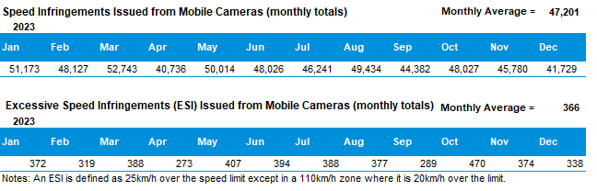

The National Picture
State | Lives Lost (12 months to December)
 | 2023 | 2022 | 2021 | 2020 | 2023 v 2022
New South Wales | 351 | 281 | 275 | 284 | +70 | (+25%)
Victoria | 295 | 241 | 234 | 211 | +54 | (+22%)
Queensland | 276 | 297 | 277 | 278 | -21 | (-7%)
South Australia | 117 | 71 | 99 | 93 | +46 | (+65%)
Western Australia | 159 | 175 | 166 | 155 | -16 | (-9%)
Tasmania | 35 | 51 | 35 | 37 | -16 | (-31%)
Northern Territory | 31 | 52 | 35 | 31 | -21 | (-40%)
Australian Capital Territory | 4 | 18 | 11 | 7 | -14 | (-78%)
Australia | 1,268 | 1,171 | 1,130 | 1,096 | +97 | (+8%)
Australia minus Victoria | 973 | 930 | 898 | 885 | +43 | (+5%)
State | Lives Lost per 10,000 registered vehicles |  |  | Fatalities per 100,000 population
 | (12 months to December) |  |  | (12 months to December)
 | 2023 | 2022 | 2021 | 2023 | 2022 | 2021
New South Wales | 0.56 | 0.46 | 0.46 | 4.21 | 3.45 | 3.40
Victoria | 0.54 | 0.45 | 0.45 | 4.33 | 3.64 | 3.57
Queensland | 0.59 | 0.66 | 0.63 | 5.06 | 5.58 | 5.31
South Australia | 0.74 | 0.46 | 0.66 | 6.32 | 3.90 | 5.49
Western Australia | 0.64 | 0.73 | 0.71 | 5.52 | 6.28 | 6.04
Tasmania | 0.65 | 0.97 | 0.68 | 6.11 | 8.92 | 6.16
Northern Territory | 1.86 | 3.15 | 2.14 | 12.28 | 20.28 | 14.04
Australian Capital Territory | 0.12 | 0.55 | 0.34 | 0.86 | 3.94 | 2.43
Australia | 0.59 | 0.56 | 0.55 | 4.76 | 4.51 | 4.40
Australia minus Victoria | 0.63 | 0.61 | 0.60 | 4.91 | 4.80 | 4.69

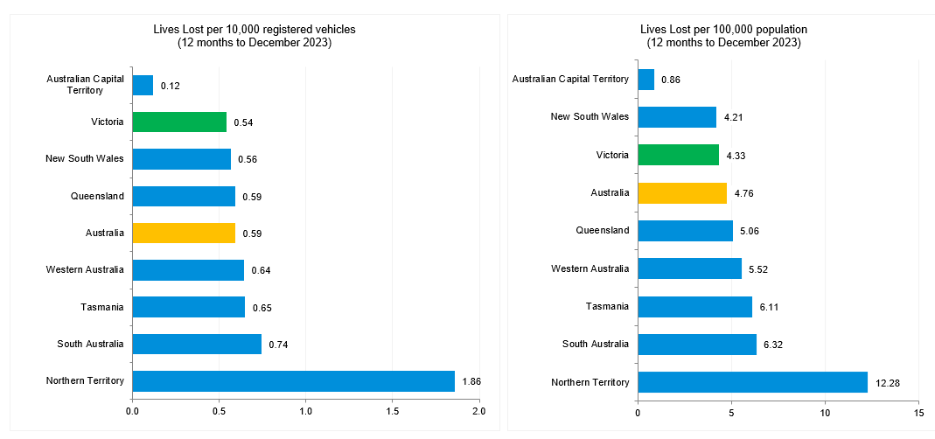
Source: Road Deaths Australia | Bureau of Infrastructure and Transport Research Economics (bitre.gov.au)

International Road Safety Comparison
Selected OECD countries, Australia, and Victoria, 2000, 2010, 2015, 2020, and 2021 to 2022.

Lives lost rate per 100,000 population.
Countries | 2000 | 2010 | 2015 | 2020 | 2021 | 2022
Australia | 9.5 | 6.1 | 5.1 | 4.3 | 4.3 | 4.6
Canada | 9.5 | 6.6 | 5.3 | 4.6 | 4.6* | -
New Zealand | 12.0 | 8.6 | 6.9 | 6.0 | 6.2 | 7.3*
Norway | 7.6 | 4.3 | 2.3 | 1.7 | 1.5 | 2.1
Sweden | 6.7 | 2.8 | 2.7 | 2.0 | 2.0 | 2.2
Switzerland | 8.2 | 4.2 | 3.1 | 2.6 | 2.3 | 2.7
United Kingdom | 6.1 | 3.0 | 2.8 | 2.3 | 2.4 | 2.6
United States | 14.9 | 10.7 | 11.1 | 11.8 | 12.9 | -
Victoria | 8.7 | 5.3 | 4.2 | 3.2 | 3.5 | 3.6
.

Lives lost rate per100 million vehicle kilometres travelled (VKT)
Countries | 2000 | 2010 | 2015 | 2020 | 2021 | 2022
Australia | 1.0 | 0.6 | 0.5 | 0.4 | 0.5 | 0.5
Canada | 0.9 | 0.7 | 0.5 | 0.5 | 0.4 | -
New Zealand | 1.3 | 0.9 | 0.7 | 0.7 | 0.7 | 0.8
Norway | 1.0 | 0.5 | 0.3 | 0.2 | 0.2 | -
Sweden | 0.9 | 0.3 | 0.3 | 0.3 | 0.3 | 0.3
Switzerland | 1.1 | 0.5 | 0.4 | 0.4 | 0.3 | -
United Kingdom | 0.8 | 0.4 | 0.3 | 0.3 | 0.3 | -
United States | 0.9 | 0.7 | 0.7 | 0.8 | 0.8 | -
Victoria | 0.8 | 0.5 | 0.4 | 0.3 | - | -

Lives lost rate per 10,000 registered vehicles

Countries | 2000 | 2010 | 2015 | 2020 | 2021 | 2022
Australia | 1.5 | 0.8 | 0.7 | 0.6 | 0.6* | 0.6*
Canada | 1.6 | 1.0 | 0.8 | 0.7 | - | -
New Zealand | 1.8 | 1.2 | 0.9 | 0.7 | - | -
Norway | 1.2 | 0.6 | 0.3 | 0.2 | - | -
Sweden | 1.2 | 0.5 | 0.5 | 0.3 | 0.3 | -
Switzerland | 1.3 | 0.6 | 0.4 | 0.4 | 0.3 | -
United Kingdom | 1.2 | 0.5 | 0.5 | 0.4 | - | -
United States | 1.9 | 1.3 | 1.3 | 1.3 | - | -
Victoria | 1.2 | 0.7 | 0.6 | 0.4 | 0.4 | 0.5

* Provisional estimates; - Unknown.

Source: https://www.bitre.gov.au/publications/ongoing/international_road_safety_comparisons

Lives lost rate per 100,000 population - OECD countries, 2022.

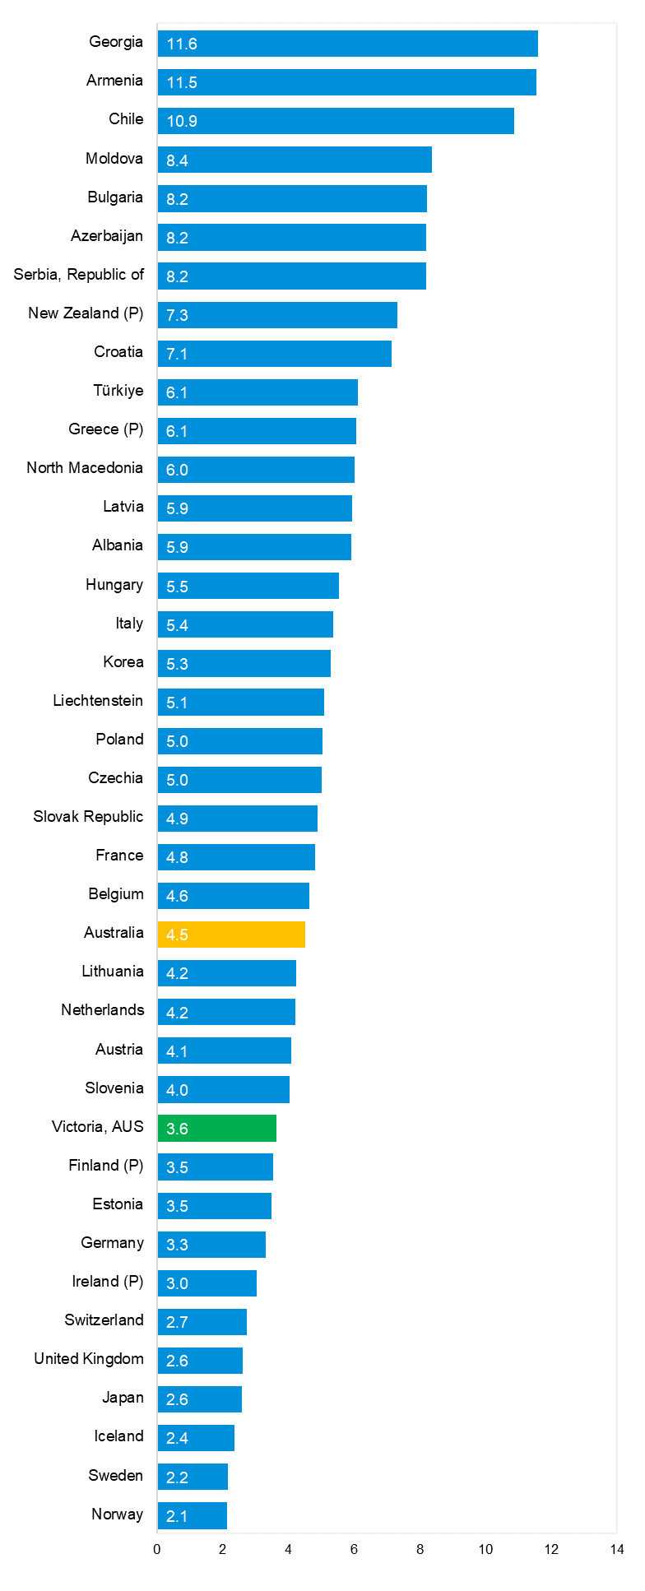
Source: Bureau of Infrastructure and Transport Research Economics

Explanations and references
LGA: Local Government Areas. Crash locations for acute hospitalised claims are assigned to LGA’s based on the crash postcode recorded by Victoria Police. Crash locations for fatal crashes are coded exactly to an LGA by Victoria Police.
Claimants: Refers to people injured in transport accidents who have an accepted claim with the TAC.
Hospitalisation: refers to all hospital admission that occurred within 7 days of accident.

Useful websites
TAC Sites
- TAC Safety (Road Safety) www.tacsafety.com.au
- TAC How safe is your car www.howsafeisyourcar.com.au
- TAC How safe is your first car www.howsafeisyourfirstcar.com.au
- TAC Motorcycle Safety Website www.spokes.com.au
- TAC Corporate site www.tac.vic.gov.au
- Drivesmart www.drivesmart.vic.gov.au
- Ridesmart www.ridesmartonline.com.au

Victorian Sites
- VicRoads www.vicroads.vic.gov.au
- Victoria Police www.police.vic.gov.au
- Parliamentary Road Safety Committee https://www.parliament.vic.gov.au/57th-parliament/rsc
- RACV www.racv.com.au
- Monash University Accident Research Centre www.monash.edu.au/muarc
- Cameras Save Lives www.camerassavelives.vic.gov.au
- VicRoads Learner Driver Site www.lsite.vicroads.vic.gov.au/Learners
- Road Safety Education Victoria www.roadsafetyeducation.vic.gov.au

National and Interstate Sites
- ARRB Transport Research www.arrb.com.au
- Australian Transport Safety Bureau www.atsb.gov.au
- Motor Accidents Authority (NSW) www.maa.nsw.gov.au
- Motor Accidents Insurance Board (TAS) www.maib.tas.gov.au
- Motor Accident Commission, Allianz (SA) www.mac.sa.gov.au
- Motor Accidents Compensation, TIO, (NT) www.tiofi.com.au/mac
- Insurance Commission of Western Australia www.icwa.wa.gov.au
- Motor Accident Insurance Commission (QLD) www.maic.qld.gov.au

International Sites
- National Highway Traffic Safety Admin (USA) www.nhtsa.dot.gov
- Swedish Road and Transport Institute (VTI) www.vti.se
- SWOV Institute for Road Safety Research www.swov.nl

Related Sites
- Alcohol and Drug Foundation www.adf.org.au

Graphs of Lives Lost and Hospitalised Claims

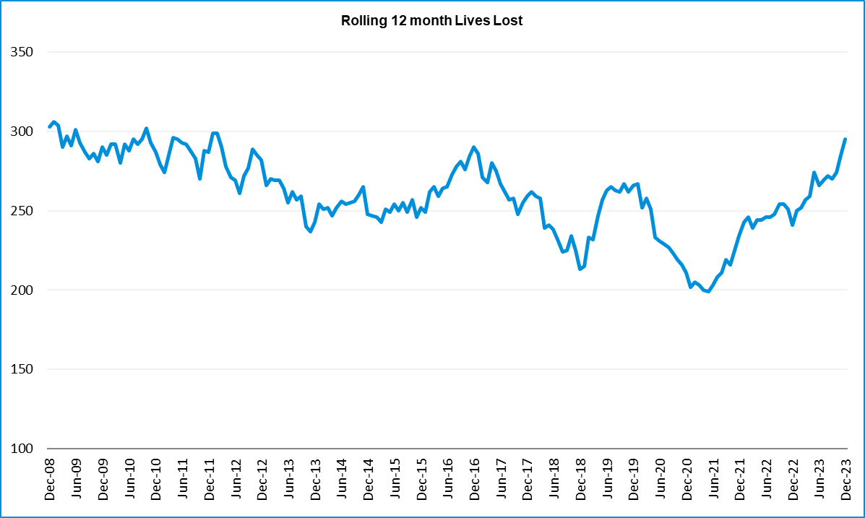

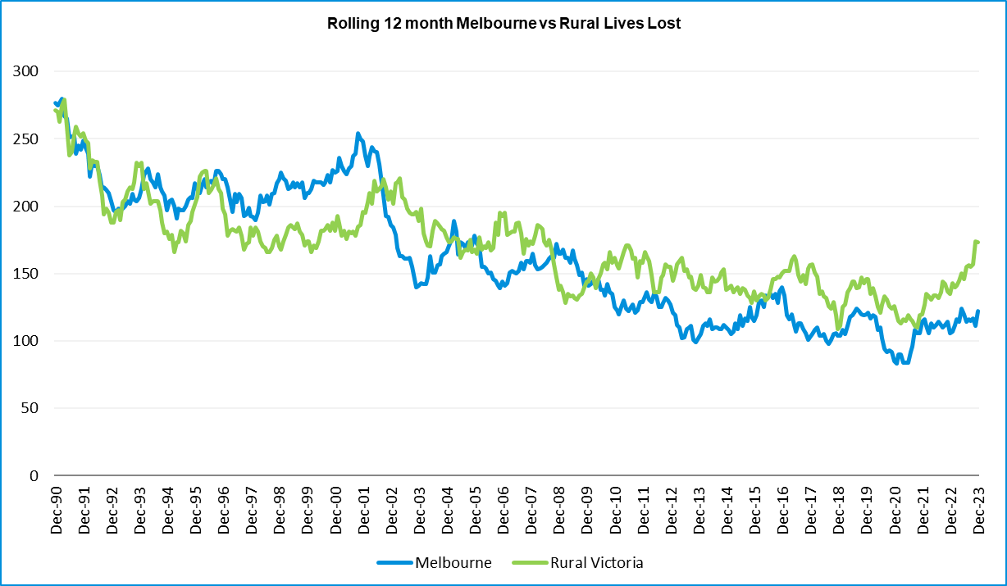

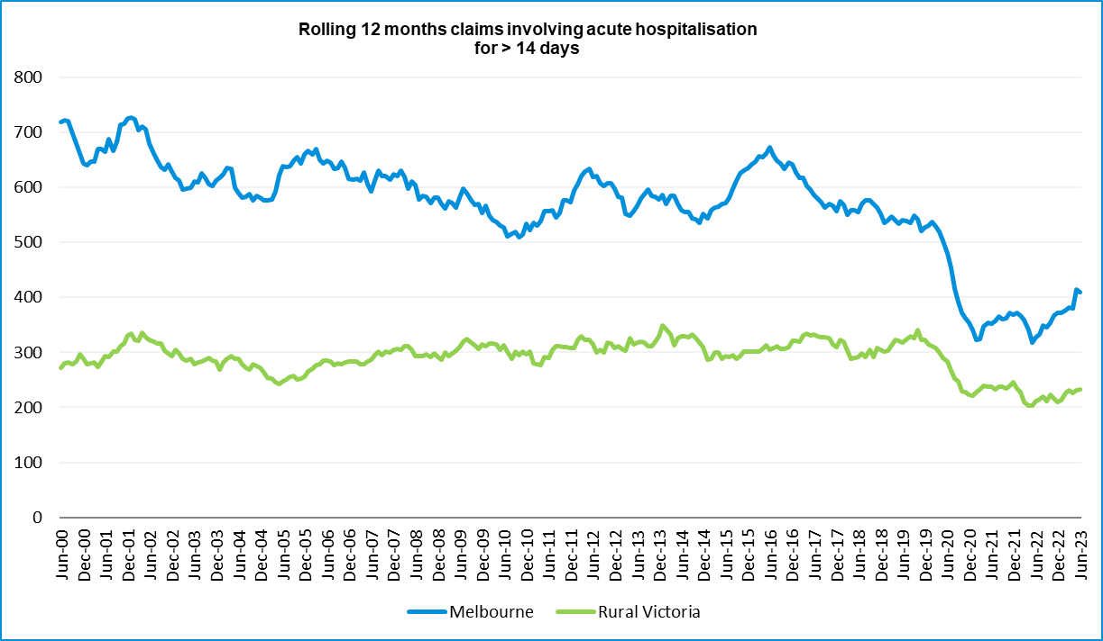

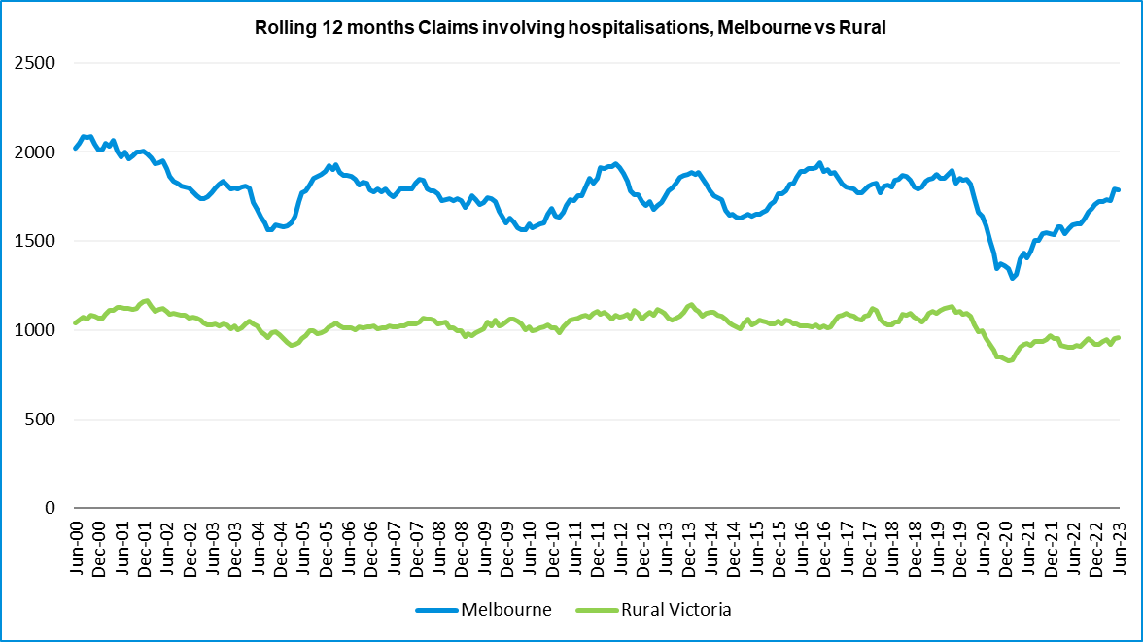

Victorian monthly lives lost since 1951.
Year | Jan |  | Feb |  | Mar |  | Apr |  | May |  | Jun |  | Jul |  | Aug |  | Sep |  | Oct |  | Nov |  | Dec |  | Total
1951 |  |  |  |  |  |  |  |  |  |  |  |  | 61 |  | 59 |  | 52 |  | 38 |  | 29 |  | 41
1952 | 45 |  | 40 |  | 54 |  | 61 |  | 54 |  | 69 |  | 67 |  | 55 |  | 44 |  | 44 |  | 31 |  | 20 |  | 584
1953 | 23 |  | 28 |  | 54 |  | 58 |  | 49 |  | 42 |  | 50 |  | 37 |  | 44 |  | 27 |  | 36 |  | 32 |  | 480
1954 | 44 |  | 42 |  | 28 |  | 60 |  | 55 |  | 36 |  | 63 |  | 33 |  | 25 |  | 52 |  | 30 |  | 41 |  | 509
1955 | 44 |  | 36 |  | 45 |  | 55 |  | 48 |  | 56 |  | 64 |  | 44 |  | 44 |  | 32 |  | 40 |  | 40 |  | 548
1956 | 34 |  | 48 |  | 51 |  | 67 |  | 53 |  | 65 |  | 71 |  | 47 |  | 39 |  | 39 |  | 44 |  | 48 |  | 606
1957 | 50 |  | 41 |  | 46 |  | 58 |  | 52 |  | 54 |  | 57 |  | 53 |  | 51 |  | 46 |  | 32 |  | 49 |  | 589
1958 | 50 |  | 38 |  | 42 |  | 58 |  | 54 |  | 41 |  | 54 |  | 53 |  | 57 |  | 40 |  | 57 |  | 52 |  | 596
1959 | 50 |  | 57 |  | 61 |  | 50 |  | 75 |  | 55 |  | 42 |  | 48 |  | 52 |  | 55 |  | 63 |  | 63 |  | 671
1960 | 49 |  | 53 |  | 57 |  | 76 |  | 70 |  | 70 |  | 67 |  | 62 |  | 61 |  | 77 |  | 52 |  | 66 |  | 760
1961 | 63 |  | 57 |  | 68 |  | 74 |  | 58 |  | 68 |  | 78 |  | 82 |  | 59 |  | 62 |  | 60 |  | 65 |  | 794
1962 | 65 |  | 41 |  | 76 |  | 78 |  | 72 |  | 80 |  | 70 |  | 77 |  | 62 |  | 53 |  | 64 |  | 70 |  | 808
1963 | 67 |  | 56 |  | 65 |  | 85 |  | 66 |  | 68 |  | 77 |  | 55 |  | 55 |  | 58 |  | 61 |  | 67 |  | 780
1964 | 73 |  | 71 |  | 78 |  | 71 |  | 83 |  | 89 |  | 80 |  | 89 |  | 67 |  | 66 |  | 62 |  | 75 |  | 904
1965 | 63 |  | 64 |  | 86 |  | 88 |  | 80 |  | 87 |  | 79 |  | 69 |  | 81 |  | 77 |  | 68 |  | 87 |  | 929
1966 | 75 |  | 59 |  | 75 |  | 103 |  | 74 |  | 86 |  | 87 |  | 80 |  | 75 |  | 66 |  | 90 |  | 85 |  | 955
1967 | 61 |  | 79 |  | 91 |  | 97 |  | 81 |  | 71 |  | 59 |  | 67 |  | 70 |  | 68 |  | 60 |  | 83 |  | 887
1968 | 70 |  | 78 |  | 86 |  | 78 |  | 73 |  | 76 |  | 73 |  | 77 |  | 72 |  | 80 |  | 81 |  | 105 |  | 949
1969 | 79 |  | 68 |  | 79 |  | 87 |  | 86 |  | 77 |  | 87 |  | 83 |  | 87 |  | 83 |  | 94 |  | 101 |  | 1011
1970 | 85 |  | 84 |  | 106 |  | 80 |  | 87 |  | 88 |  | 110 |  | 106 |  | 78 |  | 95 |  | 68 |  | 74 |  | 1061
1971 | 83 |  | 75 |  | 77 |  | 68 |  | 76 |  | 86 |  | 85 |  | 72 |  | 78 |  | 73 |  | 74 |  | 76 |  | 923
1972 | 61 |  | 62 |  | 75 |  | 82 |  | 75 |  | 71 |  | 98 |  | 85 |  | 83 |  | 62 |  | 80 |  | 81 |  | 915
1973 | 75 |  | 75 |  | 95 |  | 85 |  | 64 |  | 66 |  | 61 |  | 85 |  | 89 |  | 88 |  | 66 |  | 86 |  | 935
1974 | 56 |  | 62 |  | 81 |  | 60 |  | 70 |  | 73 |  | 67 |  | 62 |  | 53 |  | 70 |  | 80 |  | 72 |  | 806
1975 | 67 |  | 65 |  | 87 |  | 73 |  | 97 |  | 94 |  | 57 |  | 75 |  | 69 |  | 66 |  | 71 |  | 89 |  | 910
1976 | 79 |  | 78 |  | 88 |  | 78 |  | 69 |  | 79 |  | 60 |  | 70 |  | 82 |  | 78 |  | 77 |  | 100 |  | 938
1977 | 65 |  | 71 |  | 89 |  | 79 |  | 65 |  | 79 |  | 70 |  | 91 |  | 68 |  | 74 |  | 96 |  | 107 |  | 954
1978 | 75 |  | 54 |  | 95 |  | 63 |  | 64 |  | 69 |  | 68 |  | 77 |  | 65 |  | 84 |  | 83 |  | 72 |  | 869
1979 | 63 |  | 60 |  | 86 |  | 75 |  | 45 |  | 64 |  | 66 |  | 75 |  | 69 |  | 79 |  | 72 |  | 93 |  | 847
1980 | 48 |  | 55 |  | 66 |  | 59 |  | 47 |  | 56 |  | 60 |  | 53 |  | 45 |  | 58 |  | 61 |  | 49 |  | 657
1981 | 69 |  | 60 |  | 58 |  | 61 |  | 74 |  | 65 |  | 61 |  | 63 |  | 68 |  | 71 |  | 59 |  | 57 |  | 766
1982 | 55 |  | 53 |  | 59 |  | 59 |  | 67 |  | 45 |  | 47 |  | 71 |  | 53 |  | 69 |  | 65 |  | 66 |  | 709
1983 | 42 |  | 59 |  | 53 |  | 63 |  | 62 |  | 61 |  | 65 |  | 51 |  | 59 |  | 43 |  | 54 |  | 52 |  | 664
1984 | 65 |  | 48 |  | 58 |  | 50 |  | 56 |  | 48 |  | 46 |  | 50 |  | 71 |  | 53 |  | 55 |  | 58 |  | 658
1985 | 56 |  | 47 |  | 50 |  | 65 |  | 75 |  | 50 |  | 51 |  | 50 |  | 58 |  | 61 |  | 56 |  | 64 |  | 683
1986 | 56 |  | 50 |  | 70 |  | 69 |  | 59 |  | 53 |  | 42 |  | 54 |  | 54 |  | 52 |  | 59 |  | 51 |  | 669
1987 | 62 |  | 43 |  | 57 |  | 52 |  | 63 |  | 59 |  | 62 |  | 49 |  | 62 |  | 61 |  | 55 |  | 80 |  | 705
1988 | 49 |  | 58 |  | 69 |  | 54 |  | 79 |  | 50 |  | 54 |  | 52 |  | 64 |  | 59 |  | 43 |  | 70 |  | 701
1989 | 76 |  | 65 |  | 80 |  | 59 |  | 67 |  | 73 |  | 52 |  | 65 |  | 82 |  | 50 |  | 41 |  | 66 |  | 776
1990 | 48 |  | 44 |  | 55 |  | 39 |  | 56 |  | 64 |  | 41 |  | 34 |  | 48 |  | 35 |  | 40 |  | 44 |  | 548
1991 | 45 |  | 39 |  | 70 |  | 30 |  | 34 |  | 29 |  | 44 |  | 47 |  | 41 |  | 36 |  | 35 |  | 53 |  | 503
1992 | 34 |  | 33 |  | 34 |  | 47 |  | 33 |  | 29 |  | 23 |  | 27 |  | 28 |  | 38 |  | 30 |  | 40 |  | 396
1993 | 27 |  | 40 |  | 37 |  | 39 |  | 44 |  | 33 |  | 33 |  | 27 |  | 34 |  | 39 |  | 43 |  | 40 |  | 436
1994 | 36 |  | 31 |  | 44 |  | 35 |  | 27 |  | 33 |  | 29 |  | 37 |  | 17 |  | 27 |  | 32 |  | 30 |  | 378
1995 | 38 |  | 35 |  | 26 |  | 33 |  | 34 |  | 41 |  | 27 |  | 34 |  | 34 |  | 32 |  | 38 |  | 46 |  | 418
1996 | 40 |  | 47 |  | 35 |  | 38 |  | 28 |  | 29 |  | 30 |  | 35 |  | 49 |  | 24 |  | 33 |  | 30 |  | 418
Year |  | Jan |  | Feb |  | Mar |  | Apr |  | May |  | Jun |  | Jul |  | Aug |  | Sep |  | Oct |  | Nov |  | Dec |  | Total
1997 |  | 36 |  | 25 |  | 30 |  | 30 |  | 40 |  | 22 |  | 39 |  | 26 |  | 26 |  | 29 |  | 39 |  | 35 |  | 377
1998 |  | 29 |  | 29 |  | 32 |  | 36 |  | 31 |  | 22 |  | 40 |  | 19 |  | 37 |  | 36 |  | 49 |  | 30 |  | 390
1999 |  | 32 |  | 31 |  | 35 |  | 35 |  | 34 |  | 24 |  | 35 |  | 26 |  | 28 |  | 38 |  | 29 |  | 37 |  | 384
2000 |  | 32 |  | 26 |  | 46 |  | 32 |  | 39 |  | 32 |  | 33 |  | 29 |  | 36 |  | 29 |  | 44 |  | 29 |  | 407
2001 |  | 44 |  | 30 |  | 31 |  | 32 |  | 31 |  | 41 |  | 34 |  | 37 |  | 35 |  | 51 |  | 41 |  | 37 |  | 444
2002 |  | 32 |  | 31 |  | 45 |  | 31 |  | 45 |  | 32 |  | 27 |  | 25 |  | 31 |  | 30 |  | 31 |  | 37 |  | 397
2003 |  | 21 |  | 41 |  | 36 |  | 28 |  | 31 |  | 28 |  | 20 |  | 23 |  | 23 |  | 24 |  | 24 |  | 31 |  | 330
2004 |  | 32 |  | 22 |  | 30 |  | 30 |  | 46 |  | 28 |  | 27 |  | 26 |  | 22 |  | 28 |  | 25 |  | 27 |  | 343
2005 |  | 33 |  | 27 |  | 47 |  | 21 |  | 29 |  | 23 |  | 30 |  | 25 |  | 25 |  | 33 |  | 17 |  | 36 |  | 346
2006 |  | 24 |  | 37 |  | 23 |  | 23 |  | 27 |  | 23 |  | 25 |  | 22 |  | 43 |  | 20 |  | 31 |  | 39 |  | 337
2007 |  | 23 |  | 23 |  | 32 |  | 25 |  | 26 |  | 28 |  | 28 |  | 20 |  | 23 |  | 37 |  | 26 |  | 41 |  | 332
2008 |  | 28 |  | 20 |  | 37 |  | 25 |  | 25 |  | 20 |  | 27 |  | 27 |  | 18 |  | 25 |  | 26 |  | 25 |  | 303
2009 |  | 31 |  | 18 |  | 23 |  | 32 |  | 19 |  | 30 |  | 19 |  | 21 |  | 14 |  | 28 |  | 21 |  | 34 |  | 290
2010 |  | 26 |  | 25 |  | 23 |  | 20 |  | 31 |  | 26 |  | 26 |  | 18 |  | 17 |  | 35 |  | 12 |  | 28 |  | 287
2011 |  | 18 |  | 20 |  | 34 |  | 31 |  | 30 |  | 24 |  | 25 |  | 14 |  | 12 |  | 22 |  | 30 |  | 27 |  | 287
2012 |  | 30 |  | 20 |  | 25 |  | 19 |  | 23 |  | 22 |  | 18 |  | 25 |  | 17 |  | 33 |  | 25 |  | 22 |  | 282
2013 |  | 14 |  | 24 |  | 24 |  | 19 |  | 18 |  | 13 |  | 24 |  | 20 |  | 19 |  | 15 |  | 23 |  | 30 |  | 243
2014 |  | 25 |  | 21 |  | 25 |  | 14 |  | 23 |  | 17 |  | 22 |  | 21 |  | 20 |  | 19 |  | 28 |  | 13 |  | 248
2015 |  | 24 |  | 20 |  | 22 |  | 22 |  | 21 |  | 22 |  | 18 |  | 26 |  | 14 |  | 27 |  | 17 |  | 19 |  | 252
2016 |  | 21 |  | 33 |  | 25 |  | 16 |  | 26 |  | 23 |  | 26 |  | 31 |  | 17 |  | 22 |  | 25 |  | 25 |  | 290
2017 |  | 17 |  | 18 |  | 22 |  | 28 |  | 21 |  | 15 |  | 21 |  | 26 |  | 18 |  | 12 |  | 32 |  | 29 |  | 259
2018 |  | 20 |  | 15 |  | 21 |  | 9 |  | 23 |  | 12 |  | 15 |  | 18 |  | 19 |  | 21 |  | 23 |  | 17 |  | 213
2019 |  | 22 |  | 33 |  | 20 |  | 24 |  | 33 |  | 18 |  | 17 |  | 16 |  | 18 |  | 26 |  | 18 |  | 21 |  | 266
2020 |  | 23 |  | 18 |  | 26 |  | 17 |  | 15 |  | 16 |  | 15 |  | 14 |  | 14 |  | 22 |  | 15 |  | 16 |  | 211
2021 |  | 14 |  | 21 |  | 24 |  | 14 |  | 14 |  | 20 |  | 20 |  | 17 |  | 22 |  | 19 |  | 24 |  | 25 |  | 234
2022 |  | 23 |  | 24 |  | 17 |  | 19 |  | 14 |  | 22 |  | 20 |  | 19 |  | 28 |  | 19 |  | 21 |  | 15 |  | 241
2023 |  | 32 |  | 26 |  | 22 |  | 21 |  | 29 |  | 14 |  | 23 |  | 22 |  | 26 |  | 23 |  | 32 |  | 25 |  | 295
Average |  | 45 |  | 43 |  | 52 |  | 49 |  | 49 |  | 47 |  | 47 |  | 46 |  | 45 |  | 46 |  | 46 |  | 51 |  | 572
Maximum |  | 85 |  | 84 |  | 106 |  | 103 |  | 97 |  | 94 |  | 110 |  | 106 |  | 89 |  | 95 |  | 96 |  | 107 |  | 1,061
Minimum |  | 14 |  | 15 |  | 17 |  | 9 |  | 14 |  | 12 |  | 15 |  | 14 |  | 12 |  | 12 |  | 12 |  | 13 |  | 211
Past 10-years
Average |  | 21 |  | 22 |  | 23 |  | 18 |  | 21 |  | 18 |  | 20 |  | 21 |  | 19 |  | 21 |  | 23 |  | 21 |  | 249
Maximum |  | 30 |  | 33 |  | 26 |  | 28 |  | 33 |  | 23 |  | 26 |  | 31 |  | 28 |  | 33 |  | 32 |  | 30 |  | 290
Minimum |  | 14 |  | 15 |  | 17 |  | 9 |  | 14 |  | 12 |  | 15 |  | 14 |  | 14 |  | 12 |  | 15 |  | 13 |  | 211
Past 5-years
Average |  | 20 |  | 22 |  | 22 |  | 19 |  | 20 |  | 17 |  | 18 |  | 18 |  | 20 |  | 20 |  | 22 |  | 21 |  | 237
Maximum |  | 23 |  | 33 |  | 26 |  | 28 |  | 33 |  | 22 |  | 21 |  | 26 |  | 28 |  | 26 |  | 32 |  | 29 |  | 266
Minimum |  | 14 |  | 15 |  | 17 |  | 9 |  | 14 |  | 12 |  | 15 |  | 14 |  | 14 |  | 19 |  | 15 |  | 15 |  | 211

