Road Safety Statistics

# June 2024

## Table of contents

Notes about the data in this report 3

1. Status Report 4

1.1 Lives lost on Victorian Roads 4

1.2 Injured claimants who were admitted to hospital within 7 days of accident 5

2. Lives Lost: Rolling 12 months 6

2.1 Lives Lost: 12 months to 30th June 7

3. Injured claimants admitted to hospital within 7 days of the accident with a hospital stay of more than 14 days 8

3.1 By local government area. 9

4. Injured claimants admitted to hospital within 7 days of accident. 10

4.1 By local government area. 11

5. Lives Lost by Week (2019 to 2024). 12

6. Mobile Safety Camera Data. 14

6.1 Speed Infringements Issued from Mobile Cameras (monthly totals) 14

6.2 Excessive Speed Infringements (ESI) Issued from Mobile Cameras (monthly totals) 14

7. The National Picture – Interstate Comparison 15

7.1 Lives lost (12 months to June) 15

7.2 Lives lost per 10,000 registered vehicles and per 100,000 population (12 months to June). 15

8. International Road Safety Comparison 16

8.1 Lives lost rate per 100,000 population selected OECD Countries 16

8.2 Lives lost rate per 100 million vehicle kilometres travelled (VKT) 16

8.3 Lives lost rate per 10,000 registered vehicles 16

9. Lives lost rate per 100,000 population - OECD countries, 2022. 17

10. Useful websites 18

11. Graphs of Lives Lost and Hospitalised Claims 19

12. Victorian monthly lives lost since 1951 21

## Notes about the data in this report

* All data provided in this report is the data most recently available at time of production. Fatality data updated to the end of report month. A 6-month lag applies to hospitalised TAC claims data.
* Reporting of the hospitalised claims data is based on the claim acceptance date and excludes rejected claims and those involving interstate crashes.
* Reported data will have one extra day of exposure for leap years.
* Data is subject to revision as additional information about known accidents/claims is received, and as new accident/claim reports are received and processed.
* Crash locations for acute hospitalised claims are assigned to Local Government Areas based on the crash postcode recorded by Victoria Police. Crash locations for fatal crashes are coded exactly to a Local Government Area assigned by Victoria Police.
* Claimants refers to people injured in transport accidents who have an accepted claim with the TAC.
* Hospitalisation refers to all hospital admission that occurred within 7 days of accident.

Report prepared by:

Road Safety Division, Transport Accident Commission.

## Status Report

In the 12-month period from 1st July 2023 to 30th June 2024, 289 people lost their lives, compared to 266 lives lost during the previous 12-month period from July 2022 to the end of June 2023. This represents 23 more lives lost.

### 1.1 Lives lost on Victorian Roads

|  |  |  |  |  |  |  |
| --- | --- | --- | --- | --- | --- | --- |
| Category | 2024 | 2023 | 2022 | 2024 v 2023 | 2024 v 2022 | 5 Year Average |
| Lives Lost (Rolling 12 Month Total) | | | | | | |
| Lives Lost (to June) | 289 | 266 | 246 | +23 | +43 | 247 |
| per 10,000 vehicles | 0.53 | 0.50 | 0.47 | +0.03 | +0.06 | 0.47 |
| per 100,000 population | 4.18 | 3.96 | 3.74 | +0.22 | +0.44 | 3.71 |
| Crashes (Rolling 12 Month Total) | | | | | | |
| Fatal crashes (to June) | 267 | 247 | 229 | +20 | +38 | 230 |
| per 10,000 vehicles | 0.49 | 0.46 | 0.43 | +0.03 | +0.06 | 0.44 |
| per 100,000 population | 3.86 | 3.68 | 3.48 | +0.18 | +0.38 | 3.45 |

Victoria – Lives Lost, 12 months to June 2024

### 1.2 Injured claimants who were admitted to hospital within 7 days of accident.

Rolling 12 months to 31st December (claim acceptance date)

|  |  |  |  |  |  |  |  |  |
| --- | --- | --- | --- | --- | --- | --- | --- | --- |
| Category | 2023 | 2022 | 2021 | 2023 v 2022 | | 2023 v 2022 | | 5 Year Average |
| Claims involving an acute hospitalisation over 14 days (Rolling 12 Month Total) | | | | | | |  |  |
| Claims (to December) | 655 | 605 | 644 | +50 | (+8%) | +11 | (+2%) | 680 |
| per 10,000 vehicles | 1.21 | 1.14 | 1.23 | +0.07 | (+6%) | 0.0 | (-2%) | 1.36 |
| per 100,000 population | 9.61 | 9.14 | 9.84 | +0.47 | (+5%) | -0.2 | (-2%) | 10.67 |
| All claims involving an acute hospitalisation (Rolling 12 Month Total) | | | | | | | | |
| Claims (to December) | 5,473 | 5,289 | 5,792 | +184 | (+3%) | -319 | (-6%) | 6,010 |
| per 10,000 vehicles | 10.13 | 9.96 | 11.10 | +0.17 | (+2%) | -1.0 | (-9%) | 12.12 |
| per 100,000 population | 80.34 | 79.93 | 88.45 | +0.41 | (+1%) | -8.1 | (-9%) | 94.69 |

## Lives Lost: Rolling 12 months.

12 months to 30th June

|  |  |  |  |  |  |  |  |
| --- | --- | --- | --- | --- | --- | --- | --- |
| Category |  | 2024 | 2023 | 2012 | 2024 v 2023 | 2024 v 2022 | 5 Year Average |
| Overview | Lives Lost | 289 | 266 | 246 | +23 | +43 | 247 |
| Fatal Crashes | 267 | 247 | 229 | +20 | +38 | 230 |
| Sex | Female | 80 | 79 | 68 | +1 | +12 | 68 |
| Male | 208 | 186 | 178 | +22 | +30 | 179 |
| Road user | Bicyclist | 8 | 11 | 14 | -3 | -6 | 11 |
| Driver | 117 | 117 | 106 | 0 | +11 | 111 |
| Motorcyclist | 67 | 52 | 45 | +15 | +22 | 47 |
| Passenger | 41 | 51 | 42 | -10 | -1 | 39 |
| Pedestrian | 56 | 35 | 37 | +21 | +19 | 39 |
| Location | Melbourne | 125 | 120 | 112 | +5 | +13 | 110 |
| Rural Victoria | 164 | 146 | 134 | +18 | +30 | 137 |
| Age group | 0-4 | 3 | 3 | 3 | 0 | 0 | 3 |
| 5-15 | 10 | 6 | 6 | +4 | +4 | 5 |
| 16-17 | 5 | 4 | 9 | +1 | -4 | 5 |
| 18-20 | 22 | 21 | 23 | +1 | -1 | 18 |
| 21-25 | 18 | 29 | 18 | -11 | 0 | 23 |
| 26-29 | 20 | 24 | 18 | -4 | +2 | 21 |
| 30-39 | 42 | 41 | 29 | +1 | +13 | 37 |
| 40-49 | 36 | 30 | 30 | +6 | +6 | 29 |
| 50-59 | 41 | 31 | 27 | +10 | +14 | 29 |
| 60-69 | 32 | 27 | 37 | +5 | -5 | 30 |
| 70+ | 60 | 50 | 44 | 10 | 16 | 46 |
| Accident Type -Intersection | Adjacent direction | 37 | 42 | 23 | -5 | +14 | 30 |
| Opposing direction | 15 | 11 | 9 | +4 | +6 | 11 |
| Accident Type -  Mid-block/other | Head on | 35 | 32 | 29 | +3 | +6 | 29 |
| Same direction | 19 | 21 | 29 | -2 | -10 | 22 |
| Manoeuvre/o'taking | 13 | 13 | 10 | 0 | +3 | 12 |
| On path | 3 | 8 | 4 | -5 | -1 | 5 |
| Single vehicle | 112 | 102 | 100 | +10 | +12 | 96 |
| Other (incl peds) | 55 | 37 | 42 | +18 | +13 | 42 |

### 2.1 Lives Lost: 12 months to 30th June

|  |  |  |  |  |  |  |  |  |  |
| --- | --- | --- | --- | --- | --- | --- | --- | --- | --- |
| Category | 2024 | 2023 | 2022 | 5 Year Average | Category | 2024 | 2023 | 2022 | 5 Year Average |
| Local Government Area | | | | | **Local Government Area** | | | | |
| ALPINE | 1 | 1 | 2 | 1 | MANSFIELD | 8 | 1 | 1 | 1 |
| ARARAT | 1 | 0 | 1 | 1 | MARIBYRNONG | 2 | 2 | 0 | 1 |
| BALLARAT | 2 | 1 | 4 | 2 | MAROONDAH | 3 | 2 | 2 | 2 |
| BANYULE | 1 | 3 | 2 | 2 | MELBOURNE | 2 | 3 | 7 | 3 |
| BASS COAST | 5 | 5 | 0 | 2 | MELTON | 5 | 2 | 7 | 3 |
| BAW BAW | 6 | 5 | 5 | 4 | MERRI-BEK | 1 | 4 | 3 | 2 |
| BAYSIDE | 1 | 0 | 0 | 0 | MILDURA | 5 | 2 | 4 | 3 |
| BENALLA | 2 | 1 | 2 | 1 | MITCHELL | 8 | 5 | 5 | 4 |
| BOROONDARA | 2 | 2 | 0 | 3 | MOIRA | 4 | 13 | 5 | 5 |
| BRIMBANK | 5 | 10 | 9 | 6 | MONASH | 6 | 7 | 2 | 5 |
| BULOKE | 3 | 1 | 1 | 1 | MOONEE VALLEY | 3 | 4 | 2 | 2 |
| CAMPASPE | 6 | 7 | 7 | 4 | MOORABOOL | 5 | 2 | 2 | 3 |
| CARDINIA | 5 | 2 | 6 | 5 | MORNINGTON PENINSULA | 5 | 4 | 5 | 7 |
| CASEY | 13 | 14 | 12 | 8 | MOUNT ALEXANDER | 0 | 1 | 1 | 3 |
| CENTRAL GOLDFIELDS | 0 | 1 | 0 | 1 | MOYNE | 3 | 3 | 3 | 2 |
| COLAC-OTWAY | 1 | 3 | 4 | 3 | MURRINDINDI | 4 | 5 | 5 | 3 |
| CORANGAMITE | 1 | 5 | 4 | 4 | NILLUMBIK | 3 | 0 | 2 | 1 |
| DAREBIN | 1 | 3 | 1 | 3 | NORTHERN GRAMPIANS | 2 | 2 | 7 | 3 |
| EAST GIPPSLAND | 4 | 2 | 2 | 3 | PORT PHILLIP | 2 | 2 | 3 | 2 |
| FRANKSTON | 4 | 5 | 2 | 4 | PYRENEES | 1 | 2 | 0 | 2 |
| GANNAWARRA | 1 | 2 | 0 | 1 | QUEENSCLIFFE | 0 | 0 | 0 | 0 |
| GLEN EIRA | 3 | 2 | 3 | 2 | SOUTH GIPPSLAND | 2 | 5 | 4 | 4 |
| GLENELG | 3 | 1 | 1 | 2 | SOUTHERN GRAMPIANS | 0 | 6 | 1 | 2 |
| GOLDEN PLAINS | 1 | 3 | 2 | 3 | STONNINGTON | 3 | 0 | 1 | 1 |
| GREATER BENDIGO | 8 | 3 | 7 | 5 | STRATHBOGIE | 5 | 4 | 4 | 2 |
| GREATER DANDENONG | 9 | 1 | 4 | 3 | SURF COAST | 4 | 0 | 1 | 1 |
| GREATER GEELONG | 5 | 11 | 10 | 10 | SWAN HILL | 3 | 0 | 1 | 1 |
| GREATER SHEPPARTON | 10 | 12 | 2 | 6 | TOWONG | 2 | 2 | 2 | 2 |
| HEPBURN | 9 | 0 | 3 | 2 | WANGARATTA | 5 | 3 | 5 | 2 |
| HINDMARSH | 0 | 0 | 0 | 0 | WARRNAMBOOL | 1 | 1 | 2 | 2 |
| HOBSONS BAY | 2 | 4 | 3 | 2 | WELLINGTON | 4 | 6 | 6 | 4 |
| HORSHAM | 1 | 1 | 4 | 3 | WEST WIMMERA | 1 | 2 | 0 | 2 |
| HUME | 5 | 4 | 8 | 5 | WHITEHORSE | 3 | 2 | 2 | 1 |
| INDIGO | 7 | 1 | 2 | 2 | WHITTLESEA | 3 | 8 | 7 | 5 |
| KINGSTON | 6 | 0 | 2 | 2 | WODONGA | 1 | 2 | 2 | 1 |
| KNOX | 4 | 3 | 1 | 2 | WYNDHAM | 9 | 9 | 7 | 6 |
| LATROBE | 7 | 6 | 5 | 4 | YARRA | 3 | 4 | 4 | 2 |
| LODDON | 2 | 2 | 2 | 2 | YARRA RANGES | 8 | 11 | 4 | 7 |
| MACEDON RANGES | 5 | 3 | 3 | 3 | YARRIAMBIACK | 4 | 2 | 0 | 1 |
| MANNINGHAM | 3 | 3 | 1 | 1 |  |  |  |  |  |

## Injured claimants admitted to hospital within 7 days of the accident with a hospital stay of more than 14 days.

12 months to 31st December

|  |  |  |  |  |  |  |  |  |  |
| --- | --- | --- | --- | --- | --- | --- | --- | --- | --- |
| Category |  | 2023 | 2022 | 2021 | 2023 v 2022  Number Per cent | | 2023 v 2021  Number Per cent | | 5 Year Average |
| Overview | Claims | 655 | 605 | 644 | +50 | 8% | 11 | 2% | 680 |
| Sex | Female | 254 | 214 | 237 | +40 | 19% | 17 | 7% | 256 |
| Male | 398 | 390 | 407 | +8 | 2% | -9 | -2% | 423 |
| Road user | Bicyclist | 28 | 32 | 32 | -4 | -13% | -4 | -13% | 31 |
| Driver | 234 | 228 | 243 | +6 | 3% | -9 | -4% | 260 |
| Motorcyclist | 155 | 124 | 133 | +31 | 25% | 22 | 17% | 145 |
| Passenger | 67 | 65 | 91 | +2 | 3% | -24 | -26% | 84 |
| Pedestrian | 151 | 145 | 131 | +6 | 4% | 20 | 15% | 144 |
| Train/Tram | 3 | 5 | 8 | -2 | -40% | -5 | -63% | 5 |
| Location | Melbourne | 399 | 371 | 368 | +28 | 8% | 31 | 8% | 404 |
| Rural Victoria | 238 | 210 | 246 | +28 | 13% | -8 | -3% | 248 |
| Age group | 0-4 | 0 | 1 | 3 | -1 | -100% | -3 | -100% | 2 |
| 5-15 | 13 | 9 | 10 | +4 | 44% | 3 | 30% | 11 |
| 16-17 | 9 | 11 | 14 | -2 | -18% | -5 | -36% | 12 |
| 18-20 | 34 | 25 | 35 | +9 | 36% | -1 | -3% | 34 |
| 21-25 | 54 | 43 | 52 | +11 | 26% | 2 | 4% | 54 |
| 26-29 | 37 | 30 | 47 | +7 | 23% | -10 | -21% | 40 |
| 30-39 | 72 | 91 | 83 | -19 | -21% | -11 | -13% | 86 |
| 40-49 | 81 | 75 | 64 | +6 | 8% | 17 | 27% | 78 |
| 50-59 | 97 | 70 | 84 | +27 | 39% | 13 | 15% | 87 |
| 60-69 | 74 | 74 | 91 | 0 | 0% | -17 | -19% | 90 |
| 70+ | 184 | 176 | 161 | +8 | 5% | 23 | 14% | 186 |
| Accident Type -Intersection | Adjacent direction | 96 | 62 | 68 | +34 | 55% | 28 | 41% | 72 |
| Opposing direction | 31 | 48 | 45 | -17 | -35% | -14 | -31% | 41 |
| Accident Type –  Mid-block/other | Head on | 61 | 48 | 35 | +13 | 27% | 26 | 74% | 52 |
| Same direction | 61 | 45 | 48 | +16 | 36% | 13 | 27% | 55 |
| Manoeuvre/o’taking | 36 | 41 | 40 | -5 | -12% | -4 | -10% | 40 |
| On path | 21 | 26 | 31 | -5 | -19% | -10 | -32% | 27 |
| Single vehicle | 155 | 146 | 195 | +9 | 6% | -40 | -21% | 188 |
| Other (incl peds) | 194 | 189 | 182 | +5 | 3% | 12 | 7% | 205 |

### 3.1 By local government area.

12 months to 31st December

|  |  |  |  |  |  |  |  |  |  |
| --- | --- | --- | --- | --- | --- | --- | --- | --- | --- |
| Category | 2023 | 2022 | 2021 | 5 Year Average | Category | 2023 | 2022 | 2021 | 5 Year Average |
| Local Government Area | | | | | **Local Government Area** | | | | |
| ALPINE | 3 | 4 | 6 | 5 | MANSFIELD | 2 | 4 | 4 | 4 |
| ARARAT | 0 | 4 | 0 | 2 | MARIBYRNONG | 8 | 11 | 7 | 7 |
| BALLARAT | 17 | 10 | 14 | 11 | MAROONDAH | 3 | 4 | 8 | 7 |
| BANYULE | 4 | 11 | 7 | 6 | MELBOURNE | 17 | 18 | 23 | 17 |
| BASS COAST | 11 | 7 | 7 | 5 | MELTON | 12 | 12 | 6 | 6 |
| BAW BAW | 4 | 6 | 6 | 5 | MERRI-BEK | 18 | 13 | 16 | 14 |
| BAYSIDE | 4 | 7 | 4 | 5 | MILDURA | 3 | 2 | 8 | 4 |
| BENALLA | 2 | 6 | 1 | 2 | MITCHELL | 11 | 6 | 7 | 7 |
| BOROONDARA | 9 | 5 | 12 | 8 | MOIRA | 11 | 5 | 7 | 5 |
| BRIMBANK | 17 | 17 | 22 | 14 | MONASH | 24 | 15 | 13 | 12 |
| BULOKE | 3 | 1 | 0 | 1 | MOONEE VALLEY | 8 | 15 | 13 | 10 |
| CAMPASPE | 5 | 5 | 6 | 6 | MOORABOOL | 5 | 9 | 7 | 6 |
| CARDINIA | 13 | 12 | 16 | 11 | MORNINGTON PENINSULA | 11 | 15 | 12 | 14 |
| CASEY | 14 | 26 | 16 | 19 | MOUNT ALEXANDER | 2 | 5 | 9 | 4 |
| CENTRAL GOLDFIELDS | 2 | 2 | 4 | 3 | MOYNE | 4 | 1 | 1 | 3 |
| COLAC-OTWAY | 3 | 5 | 8 | 4 | MURRINDINDI | 4 | 4 | 1 | 4 |
| CORANGAMITE | 5 | 3 | 3 | 2 | NILLUMBIK | 5 | 4 | 4 | 6 |
| DAREBIN | 14 | 14 | 14 | 12 | NORTHERN GRAMPIANS | 3 | 2 | 2 | 2 |
| EAST GIPPSLAND | 20 | 6 | 5 | 7 | PORT PHILLIP | 9 | 7 | 13 | 9 |
| FRANKSTON | 8 | 8 | 5 | 6 | PYRENEES | 0 | 0 | 2 | 1 |
| GANNAWARRA | 2 | 1 | 3 | 2 | QUEENSCLIFFE | 0 | 0 | 0 | 1 |
| GLEN EIRA | 4 | 2 | 6 | 7 | SOUTH GIPPSLAND | 6 | 4 | 5 | 4 |
| GLENELG | 4 | 4 | 1 | 2 | SOUTHERN GRAMPIANS | 2 | 0 | 2 | 2 |
| GOLDEN PLAINS | 2 | 4 | 5 | 4 | STONNINGTON | 9 | 15 | 9 | 8 |
| GREATER BENDIGO | 17 | 12 | 14 | 13 | STRATHBOGIE | 4 | 2 | 4 | 3 |
| GREATER DANDENONG | 25 | 10 | 23 | 15 | SURF COAST | 4 | 3 | 3 | 3 |
| GREATER GEELONG | 19 | 27 | 24 | 23 | SWAN HILL | 1 | 0 | 3 | 3 |
| GREATER SHEPPARTON | 9 | 8 | 23 | 9 | TOWONG | 3 | 2 | 1 | 2 |
| HEPBURN | 6 | 3 | 5 | 3 | WANGARATTA | 2 | 1 | 1 | 2 |
| HINDMARSH | 1 | 0 | 0 | 1 | WARRNAMBOOL | 2 | 5 | 3 | 3 |
| HOBSONS BAY | 8 | 6 | 6 | 5 | WELLINGTON | 6 | 5 | 12 | 7 |
| HORSHAM | 4 | 4 | 3 | 3 | WEST WIMMERA | 2 | 0 | 0 | 0 |
| HUME | 15 | 21 | 14 | 16 | WHITEHORSE | 19 | 18 | 5 | 14 |
| INDIGO | 3 | 3 | 6 | 3 | WHITTLESEA | 24 | 22 | 14 | 16 |
| KINGSTON | 14 | 11 | 11 | 10 | WODONGA | 5 | 6 | 1 | 3 |
| KNOX | 13 | 12 | 17 | 14 | WYNDHAM | 21 | 15 | 23 | 15 |
| LATROBE | 7 | 6 | 15 | 8 | YARRA | 10 | 4 | 8 | 7 |
| LODDON | 1 | 4 | 1 | 2 | YARRA RANGES | 25 | 15 | 13 | 16 |
| MACEDON RANGES | 4 | 8 | 2 | 6 | YARRIAMBIACK | 2 | 1 | 1 | 1 |
| MANNINGHAM | 14 | 6 | 8 | 7 |  |  |  |  |  |

## Injured claimants admitted to hospital within 7 days of accident.

12 months to 31st December 2023

|  |  |  |  |  |  |  |  |  |  |
| --- | --- | --- | --- | --- | --- | --- | --- | --- | --- |
| Category |  | 2023 | 2022 | 2021 | 2023 v 2022  Number Per cent | | 2023 v 2021 Number Per cent | | 5 Year Average |
| Overview | Claims | 5,473 | 5,289 | 5,792 | +184 | 3% | -319 | -6% | 6,010 |
| Sex | Female | 2,204 | 2,220 | 2,408 | -16 | -1% | -204 | -8% | 2,510 |
| Male | 3,244 | 3,060 | 3,378 | +184 | 6% | -134 | -4% | 3,488 |
| Road user | Bicyclist | 378 | 350 | 419 | +28 | 8% | -41 | -10% | 418 |
| Driver | 2,543 | 2,517 | 2,858 | +26 | 1% | -315 | -11% | 2,917 |
| Motorcyclist | 1,038 | 925 | 999 | +113 | 12% | +39 | 4% | 1,042 |
| Passenger | 702 | 710 | 781 | -8 | -1% | -79 | -10% | 811 |
| Pedestrian | 615 | 617 | 548 | -2 | 0% | +67 | 12% | 603 |
| Train/Tram | 19 | 28 | 12 | -9 | -32% | +7 | 58% | 23 |
| Location | Melbourne | 3,531 | 3,391 | 3,626 | +140 | 4% | -95 | -3% | 3,775 |
| Rural Victoria | 1,760 | 1,665 | 1,931 | +95 | 6% | -171 | -9% | 1,908 |
| Age group | 0-4 | 28 | 24 | 42 | +4 | 17% | -14 | -33% | 35 |
| 5-15 | 168 | 137 | 157 | +31 | 23% | +11 | 7% | 160 |
| 16-17 | 94 | 83 | 107 | +11 | 13% | -13 | -12% | 100 |
| 18-20 | 341 | 318 | 411 | +23 | 7% | -70 | -17% | 408 |
| 21-25 | 571 | 552 | 674 | +19 | 3% | -103 | -15% | 677 |
| 26-29 | 410 | 406 | 500 | +4 | 1% | -90 | -18% | 499 |
| 30-39 | 873 | 931 | 1,026 | -58 | -6% | -153 | -15% | 1,015 |
| 40-49 | 765 | 710 | 772 | +55 | 8% | -7 | -1% | 822 |
| 50-59 | 786 | 722 | 812 | +64 | 9% | -26 | -3% | 827 |
| 60-69 | 627 | 643 | 597 | -16 | -2% | +30 | 5% | 659 |
| 70+ | 810 | 763 | 694 | +47 | 6% | +116 | 17% | 807 |
| Accident Type -Intersection | Adjacent direction | 957 | 796 | 861 | +161 | 20% | +96 | 11% | 884 |
| Opposing direction | 431 | 432 | 458 | -1 | 0% | -27 | -6% | 454 |
| Accident Type -  Mid-block/other | Head on | 290 | 277 | 286 | +13 | 5% | +4 | 1% | 304 |
| Same direction | 925 | 854 | 934 | +71 | 8% | -9 | -1% | 915 |
| Manoeuvre/o'taking | 357 | 332 | 414 | +25 | 8% | -57 | -14% | 367 |
| On path | 207 | 241 | 316 | -34 | -14% | -109 | -34% | 260 |
| Single vehicle | 1,115 | 1,181 | 1,392 | -66 | -6% | -277 | -20% | 1,320 |
| Other (incl peds) | 1,191 | 1,176 | 1,131 | +15 | 1% | +60 | 5% | 1,505 |

### 4.1 By local government area.

12 months to 31st December 2023

|  |  |  |  |  |  |  |  |  |  |
| --- | --- | --- | --- | --- | --- | --- | --- | --- | --- |
| Category | 2023 | 2022 | 2021 | 5 Year Average | Category | 2023 | 2022 | 2021 | 5 Year Average |
| Local Government Area | | | | | **Local Government Area** | | | | |
| ALPINE | 25 | 29 | 27 | 24 | MANSFIELD | 20 | 25 | 35 | 27 |
| ARARAT | 11 | 11 | 13 | 11 | MARIBYRNONG | 51 | 64 | 71 | 60 |
| BALLARAT | 101 | 84 | 118 | 81 | MAROONDAH | 27 | 39 | 40 | 42 |
| BANYULE | 31 | 44 | 39 | 37 | MELBOURNE | 188 | 179 | 189 | 163 |
| BASS COAST | 38 | 34 | 36 | 31 | MELTON | 94 | 109 | 71 | 71 |
| BAW BAW | 54 | 58 | 52 | 48 | MERRI_BEK | 129 | 131 | 133 | 118 |
| BAYSIDE | 58 | 69 | 69 | 62 | MILDURA | 31 | 10 | 36 | 25 |
| BENALLA | 13 | 17 | 10 | 13 | MITCHELL | 61 | 42 | 64 | 50 |
| BOROONDARA | 93 | 83 | 100 | 86 | MOIRA | 30 | 24 | 36 | 28 |
| BRIMBANK | 137 | 169 | 154 | 131 | MONASH | 147 | 138 | 132 | 126 |
| BULOKE | 17 | 7 | 7 | 6 | MOONEE VALLEY | 114 | 119 | 139 | 101 |
| CAMPASPE | 38 | 29 | 48 | 31 | MOORABOOL | 51 | 73 | 35 | 42 |
| CARDINIA | 119 | 100 | 131 | 95 | MORNINGTON PENINSULA | 158 | 129 | 136 | 125 |
| CASEY | 275 | 276 | 323 | 245 | MOUNT ALEXANDER | 22 | 19 | 21 | 16 |
| CENTRAL GOLDFIELDS | 13 | 7 | 18 | 15 | MOYNE | 28 | 28 | 17 | 22 |
| COLAC-OTWAY | 37 | 61 | 54 | 46 | MURRINDINDI | 44 | 45 | 29 | 37 |
| CORANGAMITE | 35 | 16 | 30 | 21 | NILLUMBIK | 27 | 24 | 19 | 28 |
| DAREBIN | 82 | 73 | 56 | 72 | NORTHERN GRAMPIANS | 23 | 9 | 18 | 14 |
| EAST GIPPSLAND | 54 | 36 | 48 | 36 | PORT PHILLIP | 124 | 116 | 143 | 106 |
| FRANKSTON | 97 | 78 | 100 | 91 | PYRENEES | 6 | 15 | 6 | 10 |
| GANNAWARRA | 7 | 13 | 11 | 9 | QUEENSCLIFFE | 1 | 1 | 4 | 3 |
| GLEN EIRA | 83 | 84 | 93 | 87 | SOUTH GIPPSLAND | 31 | 26 | 33 | 30 |
| GLENELG | 25 | 15 | 27 | 16 | SOUTHERN GRAMPIANS | 13 | 9 | 13 | 16 |
| GOLDEN PLAINS | 25 | 31 | 32 | 31 | STONNINGTON | 105 | 117 | 93 | 92 |
| GREATER BENDIGO | 91 | 83 | 111 | 92 | STRATHBOGIE | 25 | 19 | 26 | 23 |
| GREATER DANDENONG | 199 | 166 | 260 | 190 | SURF COAST | 51 | 45 | 66 | 48 |
| GREATER GEELONG | 317 | 368 | 396 | 310 | SWAN HILL | 11 | 10 | 15 | 14 |
| GREATER SHEPPARTON | 46 | 46 | 85 | 55 | TOWONG | 13 | 9 | 12 | 9 |
| HEPBURN | 43 | 38 | 24 | 25 | WANGARATTA | 40 | 19 | 15 | 21 |
| HINDMARSH | 9 | 8 | 5 | 9 | WARRNAMBOOL | 23 | 21 | 28 | 20 |
| HOBSONS BAY | 54 | 62 | 59 | 56 | WELLINGTON | 51 | 30 | 63 | 41 |
| HORSHAM | 15 | 19 | 27 | 21 | WEST WIMMERA | 5 | 1 | 7 | 3 |
| HUME | 202 | 211 | 215 | 181 | WHITEHORSE | 79 | 58 | 79 | 74 |
| INDIGO | 15 | 14 | 23 | 15 | WHITTLESEA | 202 | 169 | 142 | 134 |
| KINGSTON | 104 | 102 | 123 | 101 | WODONGA | 24 | 37 | 28 | 24 |
| KNOX | 83 | 98 | 115 | 93 | WYNDHAM | 178 | 141 | 169 | 146 |
| LATROBE | 60 | 44 | 65 | 58 | YARRA | 100 | 95 | 74 | 75 |
| LODDON | 11 | 13 | 8 | 11 | YARRA RANGES | 132 | 113 | 119 | 117 |
| MACEDON RANGES | 49 | 59 | 41 | 46 | YARRIAMBIACK | 4 | 8 | 8 | 5 |
| MANNINGHAM | 59 | 35 | 40 | 42 |  |  |  |  |  |

## Lives Lost by Week (2019 to 2024).

|  |  |  |  |  |  |  |  |  |
| --- | --- | --- | --- | --- | --- | --- | --- | --- |
| Week Ending | 2019 | 2020 | 2021 | 2022 | 2023 | 2024 | Cumulative 2024 | 12 month moving total |
| 7-Jan | 2 | 8 | 3 | 9 | 9 | 4 | 4 | 290 |
| 14-Jan | 5 | 4 | 1 | 4 | 4 | 8 | 12 | 294 |
| 21-Jan | 3 | 3 | 2 | 5 | 7 | 5 | 17 | 292 |
| 28-Jan | 9 | 3 | 7 | 3 | 8 | 4 | 21 | 288 |
| 4-Feb | 9 | 10 | 4 | 8 | 9 | 7 | 28 | 286 |
| 11-Feb | 5 | 4 | 8 | 6 | 9 | 4 | 32 | 281 |
| 18-Feb | 11 | 7 | 3 | 5 | 3 | 5 | 37 | 283 |
| 25-Feb | 9 | 1 | 3 | 6 | 5 | 5 | 42 | 283 |
| 3-Mar | 4 | 3 | 7 | 3 | 7 | 8 | 50 | 284 |
| 10-Mar | 4 | 7 | 9 | 2 | 6 | 9 | 59 | 287 |
| 17-Mar | 7 | 11 | 4 | 5 | 4 | 3 | 62 | 286 |
| 24-Mar | 5 | 3 | 3 | 6 | 2 | 7 | 69 | 291 |
| 31-Mar | 3 | 4 | 8 | 3 | 7 | 6 | 75 | 290 |
| 7-Apr | 9 | 5 | 3 | 6 | 3 | 8 | 83 | 295 |
| 14-Apr | 6 | 0 | 3 | 4 | 5 | 3 | 86 | 293 |
| 21-Apr | 4 | 9 | 2 | 4 | 9 | 3 | 89 | 287 |
| 28-Apr | 4 | 2 | 3 | 4 | 4 | 3 | 92 | 286 |
| 5-May | 8 | 3 | 6 | 3 | 6 | 4 | 96 | 284 |
| 12-May | 9 | 2 | 4 | 2 | 3 | 6 | 102 | 287 |
| 19-May | 8 | 5 | 3 | 7 | 7 | 7 | 109 | 287 |
| 26-May | 6 | 4 | 1 | 1 | 4 | 5 | 114 | 288 |
| 2-Jun | 4 | 1 | 2 | 5 | 12 | 6 | 120 | 282 |
| 9-Jun | 4 | 3 | 6 | 4 | 1 | 6 | 126 | 287 |
| 16-Jun | 6 | 5 | 1 | 6 | 3 | 6 | 132 | 290 |
| 23-Jun | 1 | 4 | 6 | 5 | 2 | 2 | 134 | 290 |
| 30-Jun | 6 | 6 | 8 | 3 | 5 | 4 | 138 | 289 |
| 7-Jul | 5 | 1 | 4 | 6 | 7 |  |  |  |
| 14-Jul | 3 | 2 | 5 | 5 | 3 |  |  |  |
| 21-Jul | 5 | 3 | 5 | 6 | 5 |  |  |  |
| 28-Jul | 3 | 6 | 2 | 3 | 6 |  |  |  |
| 4-Aug | 3 | 5 | 2 | 3 | 5 |  |  |  |
| 11-Aug | 4 | 1 | 4 | 4 | 5 |  |  |  |
| 18-Aug | 4 | 6 | 8 | 5 | 2 |  |  |  |
| 25-Aug | 3 | 1 | 2 | 4 | 5 |  |  |  |
| 1-Sep | 2 | 3 | 3 | 7 | 7 |  |  |  |

|  |  |  |  |  |  |  |  |  |
| --- | --- | --- | --- | --- | --- | --- | --- | --- |
| Week Ending | 2019 | 2020 | 2021 | 2022 | 2023 | 2024 | Cumulative 2024 | 12 month moving total |
| 8-Sep | 5 | 4 | 2 | 6 | 7 |  |  |  |
| 15-Sep | 5 | 3 | 10 | 5 | 5 |  |  |  |
| 22-Sep | 5 | 1 | 1 | 9 | 8 |  |  |  |
| 29-Sep | 4 | 5 | 10 | 5 | 4 |  |  |  |
| 6-Oct | 4 | 3 | 3 | 2 | 7 |  |  |  |
| 13-Oct | 9 | 6 | 3 | 7 | 4 |  |  |  |
| 20-Oct | 3 | 6 | 5 | 4 | 6 |  |  |  |
| 27-Oct | 7 | 6 | 5 | 4 | 6 |  |  |  |
| 3-Nov | 4 | 2 | 4 | 5 | 3 |  |  |  |
| 10-Nov | 5 | 4 | 9 | 3 | 11 |  |  |  |
| 17-Nov | 4 | 5 | 2 | 5 | 8 |  |  |  |
| 24-Nov | 5 | 4 | 5 | 7 | 8 |  |  |  |
| 1-Dec | 3 | 1 | 6 | 3 | 4 |  |  |  |
| 8-Dec | 5 | 5 | 6 | 4 | 4 |  |  |  |
| 15-Dec | 5 | 3 | 6 | 1 | 6 |  |  |  |
| 22-Dec | 6 | 4 | 2 | 5 | 8 |  |  |  |
| 29-Dec | 4 | 4 | 10 | 4 | 6 |  |  |  |
| 31-Dec | 0 | 0 | 0 | 0 | 1 |  |  |  |
| Total | 266 | 211 | 234 | 241 | 295 | 138 |  |  |

## Mobile Safety Camera Data.

### 6.1 Speed Infringements Issued from Mobile Cameras (monthly totals)

#### Year: 2023

|  |  |  |  |  |  |  |  |  |  |  |  |  |
| --- | --- | --- | --- | --- | --- | --- | --- | --- | --- | --- | --- | --- |
| Jan | Feb | Mar | Apr | May | Jun | Jul | Aug | Sep | Oct | Nov | Dec | Average |
| 51,173 | 48,127 | 52,743 | 40,736 | 50,014 | 48,026 | 46,241 | 49,434 | 44,382 | 48,027 | 45,780 | 41,729 | 47,201 |

### 6.2 Excessive Speed Infringements (ESI) Issued from Mobile Cameras (monthly totals)

#### Year: 2023

|  |  |  |  |  |  |  |  |  |  |  |  |  |
| --- | --- | --- | --- | --- | --- | --- | --- | --- | --- | --- | --- | --- |
| Jan | Feb | Mar | Apr | May | Jun | Jul | Aug | Sep | Oct | Nov | Dec | Average |
| 372 | 319 | 388 | 273 | 407 | 394 | 388 | 377 | 289 | 470 | 374 | 338 | 336 |

Notes: An ESI is defined as 25km/h over the speed limit except in a 110km/h zone where it is 20km/h over the limit.

## The National Picture – Interstate Comparison

### 7.1 Lives lost (12 months to June)

|  |  |  |  |  |  |  |
| --- | --- | --- | --- | --- | --- | --- |
| State | 2024 | 2023 | 2022 | 2021 | 2024 v 2023  Number Per cent | |
| New South Wales | 361 | 290 | 280 | 287 | +71 | (+24%) |
| Victoria | 289 | 266 | 244 | 203 | +23 | (+9%) |
| Queensland | 296 | 273 | 292 | 296 | +23 | (+8%) |
| South Australia | 101 | 93 | 85 | 99 | +8 | (+9%) |
| Western Australia | 175 | 176 | 155 | 169 | -1 | (-1%) |
| Tasmania | 28 | 39 | 52 | 32 | -11 | (-28%) |
| Northern Territory | 55 | 31 | 45 | 37 | +24 | (+77%) |
| Australian Capital Territory | 8 | 10 | 15 | 11 | -2 | (-20%) |
| Australia | 1,313 | 1,164 | 1,168 | 1,134 | +149 | (+13%) |
| Australia minus Victoria | 1,024 | 898 | 924 | 931 | +126 | (+14%) |

### 7.2 Lives lost per 10,000 registered vehicles and per 100,000 population (12 months to June).

|  |  |  |  |  |  |  |
| --- | --- | --- | --- | --- | --- | --- |
| State | Lives Lost per 10,000 registered vehicles  2024 2023 2022 | | | Lives Lost per 100,000 population  2024 2023 2022 | | |
| New South Wales | 0.58 | 0.47 | 0.46 | 4.28 | 3.52 | 3.45 |
| Victoria | 0.52 | 0.49 | 0.46 | 4.18 | 3.96 | 3.71 |
| Queensland | 0.62 | 0.59 | 0.66 | 5.35 | 5.06 | 5.54 |
| South Australia | 0.63 | 0.60 | 0.56 | 5.41 | 5.07 | 4.69 |
| Western Australia | 0.70 | 0.72 | 0.66 | 5.98 | 6.21 | 5.60 |
| Tasmania | 0.51 | 0.73 | 1.00 | 4.88 | 6.82 | 9.13 |
| Northern Territory | 3.28 | 1.87 | 2.74 | 21.95 | 12.18 | 17.80 |
| Australian Capital Territory | 0.24 | 0.30 | 0.46 | 1.70 | 2.17 | 3.30 |
| Australia | 0.61 | 0.55 | 0.57 | 4.87 | 4.42 | 4.52 |
| Australia minus Victoria | 0.66 | 0.58 | 0.61 | 5.11 | 4.58 | 4.80 |

## International Road Safety Comparison

Selected OECD countries, Australia, and Victoria 2000, 2010, 2015, 2020, 2021 and 2022

### 8.1 Lives lost rate per 100,000 population selected OECD Countries

|  |  |  |  |  |  |  |
| --- | --- | --- | --- | --- | --- | --- |
| Countries | 2000 | 2010 | 2015 | 2020 | 2021 | 2022 |
| Australia | 7.7 | 5.1 | 5.1 | 4.3 | 4.3 | 4.5 |
| Canada | 16.4 | 10.2 | 5.3 | 4.6 | 4.6 | - |
| New Zealand | 8.6 | 5.5 | 6.9 | 6.2 | 6.2 | 7.3 |
| Norway | 7.6 | 4.3 | 2.3 | 1.7 | 1.5 | 2.1 |
| Sweden | 6.7 | 2.8 | 2.7 | 2.0 | 2.0 | 2.2 |
| Switzerland | 9.3 | 4.6 | 3.1 | 2.6 | 2.3 | 2.8 |
| United Kingdom | 8.3 | 4.2 | 2.8 | 2.3 | 2.4 | 2.6 |
| United States | 12 | 8.6 | 11.1 | 11.8 | 12.9 | 12.8 |
| Victoria | 8.5 | 5.3 | 4.2 | 3.2 | 3.3 | 3.6 |

### 8.2 Lives lost rate per 100 million vehicle kilometres travelled (VKT)

|  |  |  |  |  |  |  |
| --- | --- | --- | --- | --- | --- | --- |
| Countries | 2000 | 2010 | 2015 | 2020 | 2021 | 2022 |
| Australia | 9.5 | 0.6 | 0.5 | 0.5 | 0.5 | 0.5 |
| Canada | 9.5 | 0.7 | 0.5 | 0.5 | 0.4 | - |
| New Zealand | 12 | 0.9 | 0.7 | 0.7 | 0.7 | - |
| Norway | 7.6 | 0.5 | 0.3 | 0.2 | 0.2 | 0.3 |
| Sweden | 6.7 | 0.3 | 0.3 | 0.3 | 0.3 | 0.3 |
| Switzerland | 8.3 | 0.5 | 0.4 | 0.4 | 0.3 | - |
| United Kingdom | - | - | - | - | - | - |
| United States | 14.9 | 0.7 | 0.7 | 0.8 | 0.9 | - |
| Victoria | - | 0.5 | 0.4 | 0.3 | 0.4 |  |

### 8.3 Lives lost rate per 10,000 registered vehicles

|  |  |  |  |  |  |  |
| --- | --- | --- | --- | --- | --- | --- |
| Countries | 2000 | 2010 | 2015 | 2020 | 2021 | 2022 |
| Australia | 2.5 | 0.9 | 0.7 | 0.6 | 0.6 | 0.6 |
| Canada | - | - | 0.8 | 0.7 | 0.7 | - |
| New Zealand | 5 | 1.4 | 0.9 | 0.8 | 0.8 | 1.0 |
| Norway | 1.8 | 0.3 | 0.3 | 0.2 | 0.2 | 0.3 |
| Sweden | 1.2 | 0.5 | 0.4 | 0.3 | 0.3 | 0.4 |
| Switzerland | 2.2 | 0.7 | 0.4 | 0.4 | 0.3 | 0.4 |
| United Kingdom | 1.2 | 0.5 | 0.5 | 0.4 | 0.4 | 0.4 |
| United States | - | - | 1.3 | 1.3 | 1.4 | - |
| Victoria | 0.9 | 0.7 | 0.6 | 0.4 | 0.4 | 0.5 |

* Source: https://www.bitre.gov.au/sites/default/files/documents/international_comparisons_2022.pdf

## Lives lost rate per 100,000 population - OECD countries, 2022.

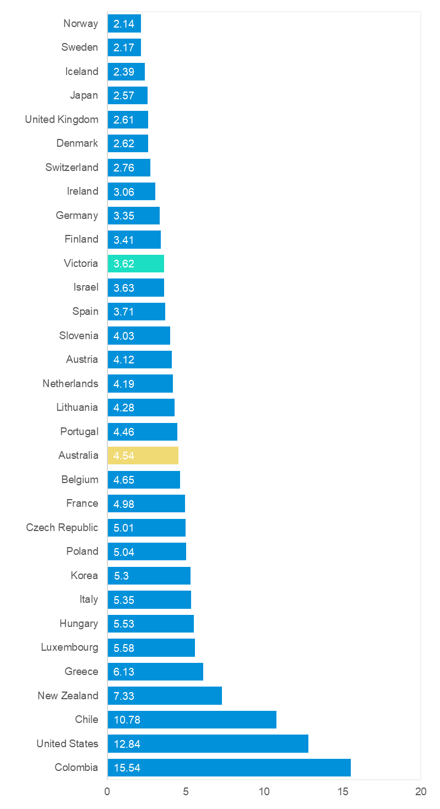

## Useful websites

#### TAC Sites

* TAC Safety (Road Safety) [tacsafety.com.au](https://www.tac.vic.gov.au/road-safety)
* TAC How safe is your car howsafeisyourcar.com.au
* TAC How safe is your first car howsafeisyourfirstcar.com.au
* TAC Motorcycle Safety Website spokes.com.au
* TAC Corporate site tac.vic.gov.au
* Drivesmart drivesmart.vic.gov.au
* Ridesmart ridesmartonline.com.au

#### Victorian Sites

* VicRoads vicroads.vic.gov.au
* Victoria Police police.vic.gov.au
* Parliamentary Road Safety Committee parliament.vic.gov.au/57th-parliament/rsc
* RACV racv.com.au
* Monash University Accident Research Centre monash.edu.au/muarc
* Cameras Save Lives camerassavelives.vic.gov.au
* VicRoads Learner Driver Site lsite.vicroads.vic.gov.au/Learners
* Road Safety Education Victoria roadsafetyeducation.vic.gov.au

#### National and Interstate Sites

* ARRB Transport Research arrb.com.au
* Australian Transport Safety Bureau atsb.gov.au
* Motor Accidents Authority (NSW) maa.nsw.gov.au
* Motor Accidents Insurance Board (TAS) maib.tas.gov.au
* Motor Accident Commission, Allianz (SA) mac.sa.gov.au
* Motor Accidents Compensation, TIO, (NT) tiofi.com.au/mac
* Insurance Commission of Western Australia icwa.wa.gov.au
* Motor Accident Insurance Commission (QLD) maic.qld.gov.au

#### International Sites

* National Highway Traffic Safety Admin (USA) nhtsa.dot.gov
* Swedish Road and Transport Institute (VTI) vti.se
* SWOV Institute for Road Safety Research swov.nl

#### Related Sites

* Alcohol and Drug Foundation adf.org.au

## Graphs of Lives Lost and Hospitalised Claims

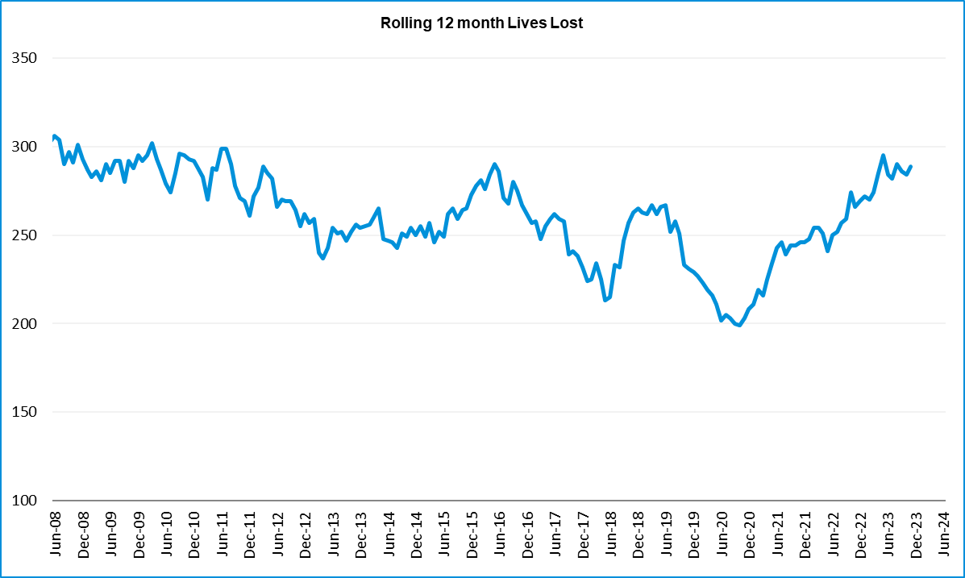

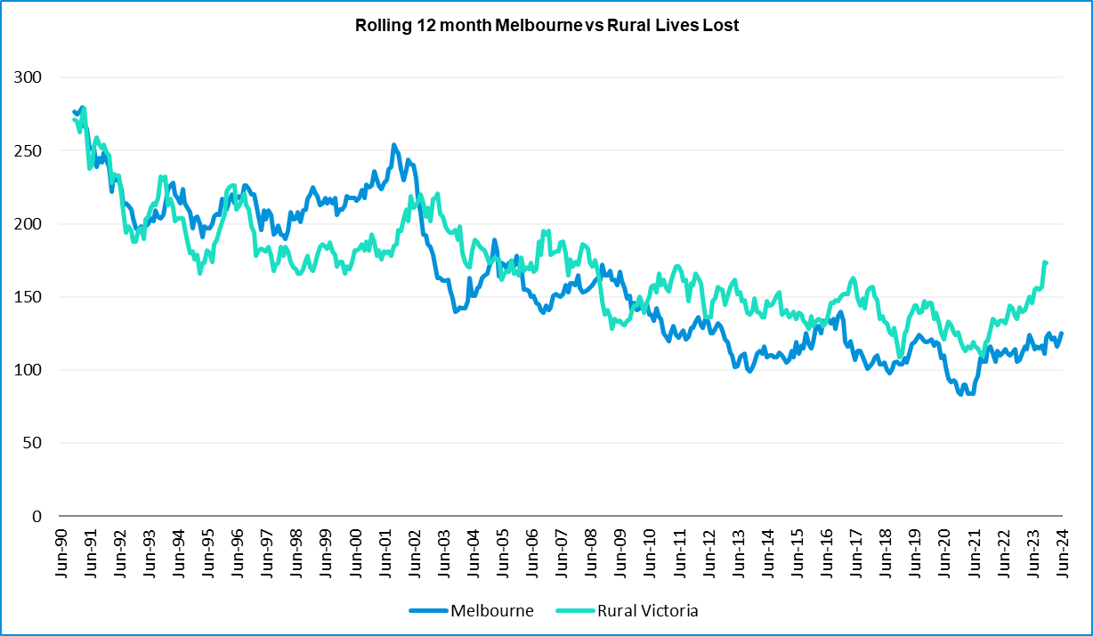

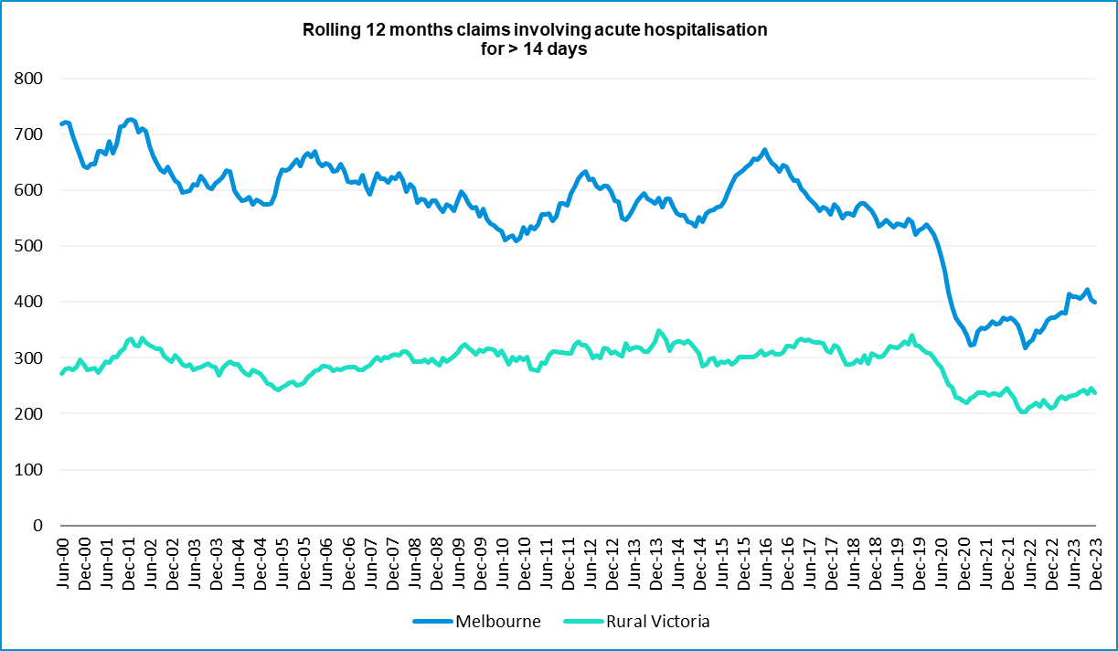

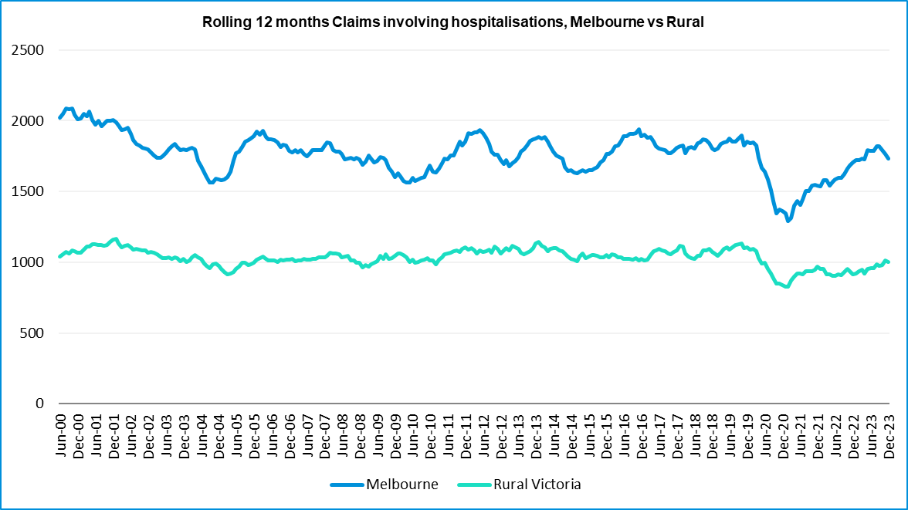

## Victorian monthly lives lost since 1951

|  |  |  |  |  |  |  |  |  |  |  |  |  |  |
| --- | --- | --- | --- | --- | --- | --- | --- | --- | --- | --- | --- | --- | --- |
| Year | Jan | Feb | Mar | Apr | May | Jun | Jul | Aug | Sep | Oct | Nov | Dec | Total |
| 1951 |  |  |  |  |  |  | 61 | 59 | 52 | 38 | 29 | 41 |  |
| 1952 | 45 | 40 | 54 | 61 | 54 | 69 | 67 | 55 | 44 | 44 | 31 | 20 | 584 |
| 1953 | 23 | 28 | 54 | 58 | 49 | 42 | 50 | 37 | 44 | 27 | 36 | 32 | 480 |
| 1954 | 44 | 42 | 28 | 60 | 55 | 36 | 63 | 33 | 25 | 52 | 30 | 41 | 509 |
| 1955 | 44 | 36 | 45 | 55 | 48 | 56 | 64 | 44 | 44 | 32 | 40 | 40 | 548 |
| 1956 | 34 | 48 | 51 | 67 | 53 | 65 | 71 | 47 | 39 | 39 | 44 | 48 | 606 |
| 1957 | 50 | 41 | 46 | 58 | 52 | 54 | 57 | 53 | 51 | 46 | 32 | 49 | 589 |
| 1958 | 50 | 38 | 42 | 58 | 54 | 41 | 54 | 53 | 57 | 40 | 57 | 52 | 596 |
| 1959 | 50 | 57 | 61 | 50 | 75 | 55 | 42 | 48 | 52 | 55 | 63 | 63 | 671 |
| 1960 | 49 | 53 | 57 | 76 | 70 | 70 | 67 | 62 | 61 | 77 | 52 | 66 | 760 |
| 1961 | 63 | 57 | 68 | 74 | 58 | 68 | 78 | 82 | 59 | 62 | 60 | 65 | 794 |
| 1962 | 65 | 41 | 76 | 78 | 72 | 80 | 70 | 77 | 62 | 53 | 64 | 70 | 808 |
| 1963 | 67 | 56 | 65 | 85 | 66 | 68 | 77 | 55 | 55 | 58 | 61 | 67 | 780 |
| 1964 | 73 | 71 | 78 | 71 | 83 | 89 | 80 | 89 | 67 | 66 | 62 | 75 | 904 |
| 1965 | 63 | 64 | 86 | 88 | 80 | 87 | 79 | 69 | 81 | 77 | 68 | 87 | 929 |
| 1966 | 75 | 59 | 75 | 103 | 74 | 86 | 87 | 80 | 75 | 66 | 90 | 85 | 955 |
| 1967 | 61 | 79 | 91 | 97 | 81 | 71 | 59 | 67 | 70 | 68 | 60 | 83 | 887 |
| 1968 | 70 | 78 | 86 | 78 | 73 | 76 | 73 | 77 | 72 | 80 | 81 | 105 | 949 |
| 1969 | 79 | 68 | 79 | 87 | 86 | 77 | 87 | 83 | 87 | 83 | 94 | 101 | 1011 |
| 1970 | 85 | 84 | 106 | 80 | 87 | 88 | 110 | 106 | 78 | 95 | 68 | 74 | 1061 |
| 1971 | 83 | 75 | 77 | 68 | 76 | 86 | 85 | 72 | 78 | 73 | 74 | 76 | 923 |
| 1972 | 61 | 62 | 75 | 82 | 75 | 71 | 98 | 85 | 83 | 62 | 80 | 81 | 915 |
| 1973 | 75 | 75 | 95 | 85 | 64 | 66 | 61 | 85 | 89 | 88 | 66 | 86 | 935 |
| 1974 | 56 | 62 | 81 | 60 | 70 | 73 | 67 | 62 | 53 | 70 | 80 | 72 | 806 |
| 1975 | 67 | 65 | 87 | 73 | 97 | 94 | 57 | 75 | 69 | 66 | 71 | 89 | 910 |
| 1976 | 79 | 78 | 88 | 78 | 69 | 79 | 60 | 70 | 82 | 78 | 77 | 100 | 938 |
| 1977 | 65 | 71 | 89 | 79 | 65 | 79 | 70 | 91 | 68 | 74 | 96 | 107 | 954 |
| 1978 | 75 | 54 | 95 | 63 | 64 | 69 | 68 | 77 | 65 | 84 | 83 | 72 | 869 |
| 1979 | 63 | 60 | 86 | 75 | 45 | 64 | 66 | 75 | 69 | 79 | 72 | 93 | 847 |
| 1980 | 48 | 55 | 66 | 59 | 47 | 56 | 60 | 53 | 45 | 58 | 61 | 49 | 657 |
| 1981 | 69 | 60 | 58 | 61 | 74 | 65 | 61 | 63 | 68 | 71 | 59 | 57 | 766 |
| 1982 | 55 | 53 | 59 | 59 | 67 | 45 | 47 | 71 | 53 | 69 | 65 | 66 | 709 |
| 1983 | 42 | 59 | 53 | 63 | 62 | 61 | 65 | 51 | 59 | 43 | 54 | 52 | 664 |
| 1984 | 65 | 48 | 58 | 50 | 56 | 48 | 46 | 50 | 71 | 53 | 55 | 58 | 658 |
| 1985 | 56 | 47 | 50 | 65 | 75 | 50 | 51 | 50 | 58 | 61 | 56 | 64 | 683 |

|  |  |  |  |  |  |  |  |  |  |  |  |  |  |
| --- | --- | --- | --- | --- | --- | --- | --- | --- | --- | --- | --- | --- | --- |
| Year | Jan | Feb | Mar | Apr | May | Jun | Jul | Aug | Sep | Oct | Nov | Dec | Total |
| 1986 | 56 | 50 | 70 | 69 | 59 | 53 | 42 | 54 | 54 | 52 | 59 | 51 | 669 |
| 1987 | 62 | 43 | 57 | 52 | 63 | 59 | 62 | 49 | 62 | 61 | 55 | 80 | 705 |
| 1988 | 49 | 58 | 69 | 54 | 79 | 50 | 54 | 52 | 64 | 59 | 43 | 70 | 701 |
| 1989 | 76 | 65 | 80 | 59 | 67 | 73 | 52 | 65 | 82 | 50 | 41 | 66 | 776 |
| 1990 | 48 | 44 | 55 | 39 | 56 | 64 | 41 | 34 | 48 | 35 | 40 | 44 | 548 |
| 1991 | 45 | 39 | 70 | 30 | 34 | 29 | 44 | 47 | 41 | 36 | 35 | 53 | 503 |
| 1992 | 34 | 33 | 34 | 47 | 33 | 29 | 23 | 27 | 28 | 38 | 30 | 40 | 396 |
| 1975 | 67 | 65 | 87 | 73 | 97 | 94 | 57 | 75 | 69 | 66 | 71 | 89 | 910 |
| 1976 | 79 | 78 | 88 | 78 | 69 | 79 | 60 | 70 | 82 | 78 | 77 | 100 | 938 |
| 1977 | 65 | 71 | 89 | 79 | 65 | 79 | 70 | 91 | 68 | 74 | 96 | 107 | 954 |
| 1978 | 75 | 54 | 95 | 63 | 64 | 69 | 68 | 77 | 65 | 84 | 83 | 72 | 869 |
| 1979 | 63 | 60 | 86 | 75 | 45 | 64 | 66 | 75 | 69 | 79 | 72 | 93 | 847 |
| 1980 | 48 | 55 | 66 | 59 | 47 | 56 | 60 | 53 | 45 | 58 | 61 | 49 | 657 |
| 1981 | 69 | 60 | 58 | 61 | 74 | 65 | 61 | 63 | 68 | 71 | 59 | 57 | 766 |
| 1982 | 55 | 53 | 59 | 59 | 67 | 45 | 47 | 71 | 53 | 69 | 65 | 66 | 709 |
| 1983 | 42 | 59 | 53 | 63 | 62 | 61 | 65 | 51 | 59 | 43 | 54 | 52 | 664 |
| 1984 | 65 | 48 | 58 | 50 | 56 | 48 | 46 | 50 | 71 | 53 | 55 | 58 | 658 |
| 1985 | 56 | 47 | 50 | 65 | 75 | 50 | 51 | 50 | 58 | 61 | 56 | 64 | 683 |
| 1986 | 56 | 50 | 70 | 69 | 59 | 53 | 42 | 54 | 54 | 52 | 59 | 51 | 669 |
| 1987 | 62 | 43 | 57 | 52 | 63 | 59 | 62 | 49 | 62 | 61 | 55 | 80 | 705 |
| 1988 | 49 | 58 | 69 | 54 | 79 | 50 | 54 | 52 | 64 | 59 | 43 | 70 | 701 |
| 1989 | 76 | 65 | 80 | 59 | 67 | 73 | 52 | 65 | 82 | 50 | 41 | 66 | 776 |
| 1990 | 48 | 44 | 55 | 39 | 56 | 64 | 41 | 34 | 48 | 35 | 40 | 44 | 548 |
| 1991 | 45 | 39 | 70 | 30 | 34 | 29 | 44 | 47 | 41 | 36 | 35 | 53 | 503 |
| 1992 | 34 | 33 | 34 | 47 | 33 | 29 | 23 | 27 | 28 | 38 | 30 | 40 | 396 |
| 1993 | 27 | 40 | 37 | 39 | 44 | 33 | 33 | 27 | 34 | 39 | 43 | 40 | 436 |
| 1994 | 36 | 31 | 44 | 35 | 27 | 33 | 29 | 37 | 17 | 27 | 32 | 30 | 378 |
| 1995 | 38 | 35 | 26 | 33 | 34 | 41 | 27 | 34 | 34 | 32 | 38 | 46 | 418 |
| 1996 | 40 | 47 | 35 | 38 | 28 | 29 | 30 | 35 | 49 | 24 | 33 | 30 | 418 |
| 1997 | 36 | 25 | 30 | 30 | 40 | 22 | 39 | 26 | 26 | 29 | 39 | 35 | 377 |
| 1998 | 29 | 29 | 32 | 36 | 31 | 22 | 40 | 19 | 37 | 36 | 49 | 30 | 390 |
| 1999 | 32 | 31 | 35 | 35 | 34 | 24 | 35 | 26 | 28 | 38 | 29 | 37 | 384 |
| 2000 | 32 | 26 | 46 | 32 | 39 | 32 | 33 | 29 | 36 | 29 | 44 | 29 | 407 |
| 2001 | 44 | 30 | 31 | 32 | 31 | 41 | 34 | 37 | 35 | 51 | 41 | 37 | 444 |
| 2002 | 32 | 31 | 45 | 31 | 45 | 32 | 27 | 25 | 31 | 30 | 31 | 37 | 397 |
| 2003 | 21 | 41 | 36 | 28 | 31 | 28 | 20 | 23 | 23 | 24 | 24 | 31 | 330 |
| 2004 | 32 | 22 | 30 | 30 | 46 | 28 | 27 | 26 | 22 | 28 | 25 | 27 | 343 |

|  |  |  |  |  |  |  |  |  |  |  |  |  |  |
| --- | --- | --- | --- | --- | --- | --- | --- | --- | --- | --- | --- | --- | --- |
| Year | Jan | Feb | Mar | Apr | May | Jun | Jul | Aug | Sep | Oct | Nov | Dec | Total |
| 2005 | 33 | 27 | 47 | 21 | 29 | 23 | 30 | 25 | 25 | 33 | 17 | 36 | 346 |
| 2006 | 24 | 37 | 23 | 23 | 27 | 23 | 25 | 22 | 43 | 20 | 31 | 39 | 337 |
| 2007 | 23 | 23 | 32 | 25 | 26 | 28 | 28 | 20 | 23 | 37 | 26 | 41 | 332 |
| 2008 | 28 | 20 | 37 | 25 | 25 | 20 | 27 | 27 | 18 | 25 | 26 | 25 | 303 |
| 2009 | 31 | 18 | 23 | 32 | 19 | 30 | 19 | 21 | 14 | 28 | 21 | 34 | 290 |
| 2010 | 26 | 25 | 23 | 20 | 31 | 26 | 26 | 18 | 17 | 35 | 12 | 28 | 287 |
| 2011 | 18 | 20 | 34 | 31 | 30 | 24 | 25 | 14 | 12 | 22 | 30 | 27 | 287 |
| 2012 | 30 | 20 | 25 | 19 | 23 | 22 | 18 | 25 | 17 | 33 | 25 | 22 | 282 |
| 2013 | 14 | 24 | 24 | 19 | 18 | 13 | 24 | 20 | 19 | 15 | 23 | 30 | 243 |
| 2014 | 25 | 21 | 25 | 14 | 23 | 17 | 22 | 21 | 20 | 19 | 28 | 13 | 248 |
| 2015 | 24 | 20 | 22 | 22 | 21 | 22 | 18 | 26 | 14 | 27 | 17 | 19 | 252 |
| 2016 | 21 | 33 | 25 | 16 | 26 | 23 | 26 | 31 | 17 | 22 | 25 | 25 | 290 |
| 2017 | 17 | 18 | 22 | 28 | 21 | 15 | 21 | 26 | 18 | 12 | 32 | 29 | 259 |
| 2018 | 20 | 15 | 21 | 9 | 23 | 12 | 15 | 18 | 19 | 21 | 23 | 17 | 213 |
| 2019 | 22 | 33 | 20 | 24 | 33 | 18 | 17 | 16 | 18 | 26 | 18 | 21 | 266 |
| 2020 | 23 | 18 | 26 | 17 | 15 | 16 | 15 | 14 | 14 | 22 | 15 | 16 | 211 |
| 2021 | 14 | 21 | 24 | 14 | 14 | 20 | 20 | 17 | 22 | 19 | 24 | 25 | 234 |
| 2022 | 23 | 24 | 17 | 19 | 14 | 22 | 20 | 19 | 28 | 19 | 21 | 15 | 241 |
| 2023 | 32 | 26 | 22 | 21 | 29 | 14 | 23 | 22 | 26 | 23 | 32 | 25 | 295 |
| 2024 | 21 | 24 | 30 | 17 | 27 | 19 |  |  |  |  |  |  |  |
| Average | 45 | 43 | 51 | 49 | 49 | 47 | 48 | 47 | 46 | 46 | 46 | 51 | 572 |
|  |  |  |  |  |  |  |  |  |  |  |  |  |  |
| Maximum | 85 | 84 | 106 | 103 | 97 | 94 | 110 | 106 | 89 | 95 | 96 | 107 | 1,061 |
| Minimum | 14 | 15 | 17 | 9 | 14 | 12 | 15 | 14 | 12 | 12 | 12 | 13 | 211 |
|  |  |  |  |  |  |  |  |  |  |  |  |  |  |
| Avg 10 years | 22 | 23 | 23 | 18 | 22 | 17 | 20 | 21 | 20 | 20 | 23 | 21 | 250 |
| Max 10 years | 32 | 33 | 26 | 28 | 33 | 23 | 26 | 31 | 28 | 27 | 32 | 30 | 295 |
| Min 10 years | 14 | 15 | 17 | 9 | 14 | 12 | 15 | 14 | 14 | 12 | 15 | 13 | 211 |
|  |  |  |  |  |  |  |  |  |  |  |  |  |  |
| Ave 5 years | 23 | 24 | 22 | 19 | 21 | 18 | 19 | 18 | 22 | 22 | 22 | 20 | 249 |
| Max 5 years | 32 | 33 | 26 | 24 | 33 | 22 | 23 | 22 | 28 | 26 | 32 | 25 | 295 |
| Min 5 years | 14 | 18 | 17 | 14 | 14 | 14 | 15 | 14 | 14 | 19 | 15 | 15 | 211 |

* END OF REPORT -