
Instructions
Occupational therapists should complete this form for all requests for ride-on-mowers and like vehicles (e.g. side-by-side and farm utility vehicles) and related equipment (e.g. tow-behind weed sprayers and trailers) for a TAC client. Please note:
- All questions must be answered in detail for the request to be considered.
- Equipment trial and site assessment must occur at the client’s property.
- Supporting evidence must be provided with the completed form including:
  - measurement recordings
  - all related notes.
- Please also attach with this form:
  - any additional relevant information
  - an itemised quote that meets TAC invoice requirements.
Any vehicle used on the Victorian road system that travels for more than two kilometres at a time in one direction is considered to be a motor vehicle. To prescribe any motor vehicle and/or vehicle modifications, use the TAC Vehicle Needs and Modification Assessment Report.

Section 1

client details
First name

Last name

TAC claim number |  | Date of accident | / /

Date of birth | / /

Client delivery address

Suburb/Town |  | Post code

Client phone number

Client email address

Contact person

Contact person phone number

Section 2

Summary
What equipment is being recommended?
For example, zero turn ride on lawn mower, tow behind weed sprayer.

Is the recommended equipment related and suited to the client’s transport accident injuries?

Is the equipment to be used on a post-accident purchased property?

Did the TAC client successfully trial the equipment at their property?

SECTION 3

CURRENT LEVEL OF FUNCTION
Describe the client’s transport accident related injuries and relevant medical history. Consider cognitive function, behaviour, and prognosis, and attached related reports.
Detail discussions held with the client’s treating medical practitioner(s). Consider the client’s capacity to safely operate the recommended equipment with consideration to current medications (e.g. may cause drowsiness), vision, mood, cognitive capacity, substance abuse issues etc.
Date | Time | Practitioner name | Discussion details and outcomes
/ /
/ /
Describe the client’s social situation. Consider informal supports, living situation, and employment

SECTION 4

SUPPLY OF THE EQUIPMENT
Do you recommend purchase or hire of the equipment?

If hire, for how long?

Is this an initial provision or replacement of equipment?

SECTION 5

CURRENT MAINTENANCE AND EQUIPMENT
Complete this section if existing services or equipment are being replaced.
Describe existing garden maintenance services (scope, frequency and duration)
How did the client maintain the property/area prior to their transport accident?
Provide details of gardening equipment used prior to the accident (specify type/model and date of purchase).
Provide details of gardening equipment currently being used or used since the accident
(specify type/model and date of purchase).
Provide the estimated value of existing equipment. Can existing equipment be used as trade-in on recommended equipment? What is the market value of the current equipment?
Specify the reason for replacement of services or equipment (e.g. limitation of current equipment).
Provide the estimated value of existing equipment. Can existing equipment be used as trade-in on recommended equipment? What is the market value of the current equipment?
Please provide any further relevant information.

SECTION 6

RECOMMENDATIONS
Outline the purpose of the equipment recommended. Consider intended ADLs, social, intended use (frequency and size of the area to be mowed).
Describe the expected measurable outcomes. Consider functional goals, increased independence and reduction in paid supports.

What is the size of area to be mowed?
Describe the equipment recommended. List model, order code and specification. Consider sizes, standard features, and standard accessories. Consider Roll-Over Protection Structure (ROPS) and seatbelt for properties that present as tipping hazards.

Are non-standard options or non-standard customisations or modifications required?
If yes, please list options and supporting clinical rationale.

Are any second-hand, used or ex-demonstration ride-on mowers suitable?
If no, please explain why these options are not considered clinically suitable for the client.

Have you considered day-to-day transportation of the equipment?

Have you considered the compatibility with existing equipment?

SECTION 7

EQUIPMENT TRIALS
Please include details of all equipment trialled. Trials should occur on site at the client’s property and cover the required area to mow, including navigation around site hazards.
Equipment type or model

Trial date | / /

Trial location

Trial duration (in minutes)
Summary of trial

Range of movement/tolerances assessed at trial | Yes, No or  Not applicable
Ability to tolerate vibration through chassis
Ability to tolerate undulations in the paddock/yard
Sufficient range of upper limb movement and strength to operate steering levers
Appropriate posture for safe and effective control was maintained
Chassis to seat height
Backrest height and shape provides adequate postural support and safe positioning
Foot position
Ability to transfer safely on and off the mower
Sufficient lower limb strength to operate the deck lifter or to use a modified lifting technique to raise and lower the cutting deck
Ability to apply adaptive techniques and demonstrated understanding of pacing principles
Injury symptoms were stable both at the completion of the trial and 24 hours afterwards
If the client has pressure care needs, have these been considered?

Environments assessed at trial | Competent, Safety concerns or  Not applicable
Operating the device on different surfaces (grass, gravel, uneven ground)
Operating the device on inclines/declines less than 15 degrees
Negotiating obstacles (trees, garden beds etc.)
Accessing all areas of the property curtilage (areas to be mowed)
Negotiating gates
Parking and storing the mower

Ride-on mower user safety assessed at trial | Yes or No
Can the client safely mount/dismount the mower?
Did the client follow instructions accurately?
Was the client able to operate the mower without any verbal prompts to ensure safe operation?
Was the client able to reverse the mower safely?
Did the client slow down appropriately, including when approaching hazards, obstacles or turning corners?
Was the client able to judge the position of the mower and manoeuvre it in small spaces (e.g. avoided running into other objects)?
Was the client able to turn the mower on and off?
Was the client able to operate the choke?
Was the client able to adjust the speed of the mower using the rabbit and tortoise lever?
Was the client able to turn the cutting blades on and off?
Does the client understand and demonstrate the ability to park the mower safely?
Does the client understand the safety feature in the seat?
Did the client demonstrate comfort/ease in the use of the mower? For example, not overwhelmed, overstimulated by operations/noise or tentative with use etc.
Does the client own Personal Protective Equipment (PPE) and acknowledge the need to use this when operating the equipment? This includes safety glasses, appropriate footwear (closed shoes/boots), helmet and ear protection.
Was the client able to maintain concentration and attention throughout the trial?
Can the client determine what they need to do in an emergency situation?

Environmental safety, hazards and precautions | Yes or No
Have you visually inspected the ground conditions at the client’s property to identify no-go zones such as embankments, retaining walls, steps, sink holes and/or other uneven ground? Consider obstacles that may be hidden by long grass.
Following inspection, are there any obstacles on the property, such as those indicated below, that present a risk of mower roll-over, or ejection of the user during use?
- Retaining walls
- Potholes
- Ditches
- Trenches
- Other (specify)
Is there a need to drive the mower above or over a slope, embankment, hill, raised section of lawn, etc. with an incline of more than 15 degrees?
Please note, the manufacturer’s guidelines for the safe working incline of the recommended equipment must be considered. Most equipment can be used safely on a slope up to 15 degrees. Inclines should be measured using an appropriate slope measurement device such as an inclinometers device or phone app.
Is there a risk of the mower rolling side-ways down an embankment or retained wall?
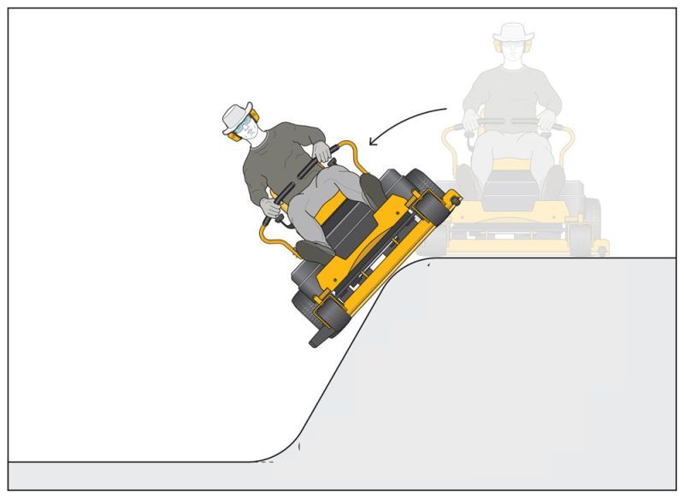

Roll-over risk | Yes, No or  Not applicable
Has a risk of rollover been identified?
Can uneven ground and steep slopes be converted from grass to other types of vegetation that do not require mowing, such as a mulched garden bed?
Can a fence along the edge of an embankment or retaining wall be constructed to prevent ride-on mowers accessing the uneven ground or steep slope?
Can an alternative means of mowing (for example a brush cutter, self-propelled walk behind mower, or a weed spray unit) be used to maintain the grass on any identified slope, embankment, hill or raised section of lawn?
Is a ride-on mower fitted with a Roll-Over Protection Structure (ROPS) and seatbelt indicated for this client?
Has the client been instructed to always wear the seat belt when the ROPS is secured in the up position?
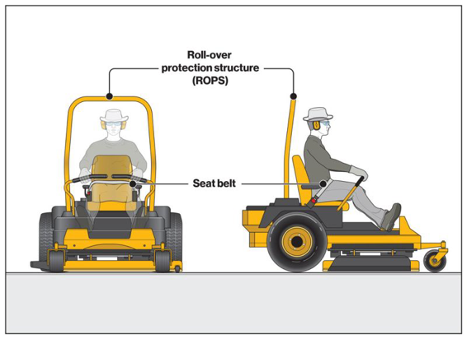
Has the client been trained to plan the method of mowing to prevent turning or reversing near uneven surfaces such as embankments?
Has the client been instructed in continuous review of environmental conditions and assessment of ground conditions prior to use, including slope, wet grass, discharged cut grass and hidden obstacles?
Has the client been instructed in the use of any tow-behind or trailer accessory to minimise the roll over risk?

Summary
In your opinion does the mower suit the client’s accident injuries?

Are modifications required to make use/positioning suitable?
If yes, please detail the required modification in Section 6 above.
Is the equipment recommended?

SECTION 8

QUOTATION
Has a written quotation meeting the TAC invoice standards been obtained?
Please attach the quotation when submitting this form.

SECTION 9

ANTICIPATED STORAGE, MAINTENANCE AND REPAIR
Is there a lockable area where the equipment can be stored?
Does the client understand and accept that they are responsible for fuel, maintenance and
servicing, parts etc.?
Consider warranty, suppliers recommended service schedule, manufacturer guidelines.

SECTION 10

TRAINING REQUIREMENTS AND DOCUMENTATION
Detail the client’s training requirements, methods used and the documents provided to the client upon delivery of equipment (in person and training documentation provided).
Training | Method used | Documents provided
Example:  Equipment operation | The client was provided with instruction and guidance on mower use on their property during the trial/s. Further set-up and orientation to the features of the mower and a skills test to ensure ongoing safe use is to be supplied on delivery | User manual
Equipment operation
The use of safety equipment (PPE, goggles, boots, and seatbelt)
Assessment of environmental conditions and site prior to use (e.g. long grass hiding objects, wet grass reducing traction/increasing risk of slips, no-mow zones)
Planning the route/method of mowing to reduce risks
Testing brakes before commencing work

Acknowledgement that instructions were demonstrated and understood.
Note: User instruction documents must be provided to the client and a copy provided to the TAC Claims Manager upon request
Is a review of the equipment upon delivery required?
If no, please explain why a review is not required.

SECTION 11

PRESCRIBING THERAPIST FOLLOW-UP
Describe the follow-up services required, including user training upon delivery and review at 12 months post supply.
Explain why follow up services or training is recommended | Frequency and duration of follow up services, e.g. single delivery/set-up/education session | Comments, including additional travel time

SECTION 12

ADDITIONAL COMMENTS AND CONSIDERATIONS
Detail any additional comments and considerations.

SECTION 13

PRESCRIBING THERAPIST DETAILS
I have discussed the information contained in this form with the client, carers, and other members of the treating team. This information included the equipment requested, the
aims, predicted outcomes, maintenance, and training requirements.

Therapist name, clinic name, billing number, address,
email and phone number
(Type details or insert image
of practice stamp)

Days/hours available

Signature
Insert image (jpg/png) of signature.
(Or print, sign and scan the form)


Print name

Date | / /

Submitting this form
Email your completed form to info@tac.vic.gov.au or to the TAC claims manager with the client’s TAC claim number in the subject line. Please attach any supporting documentation.

Privacy
The TAC will retain the information provided and may use or disclose it to make further inquiries or assist in the ongoing management of the claim or any claim for common law damages. The TAC may also be required by law to disclose this information. Without this information the TAC may be unable to determine entitlements or assess whether treatment is reasonable and may not be able to approve further benefits and treatment. If you require further information about our privacy policy, please call the TAC on 1300 654 329 or visit our website at www.tac.vic.gov.au

